*A project report on*

STOCK PREDICTION USING MACHINE LEARNING

### Submitted in partial fulfillment for the award of the degree of

**Bachelor of Technology**

### by

**ARNAB KARMAKAR (19BAI1090)**



**SCHOOL OF COMPUTER SCIENCE AND ENGINEERING**

September, 2022



**DECLARATION**

## I hereby declare that the thesis entitled “STOCK PREDICTION USING MACHINE LEARNING” submitted by me, for the award of the degree of Bachelor of Technology in Computer Science and Engineering, Vellore Institute of Technology is a record of bonafide work carried out by me under the supervision of Dr. Anita X.

## I further declare that the work reported in this thesis has not been submitted and will not be submitted, either in part or in full, for the award of any other degree or diploma in this institute or any other institute or university.

## Place: Chennai

## Date: September 2022 Signature of the Candidate



**School of Computer Science and Engineering**

CERTIFICATE

This is to certify that the report entitled **“STOCK PREDICTION USING MACHINE LEARNING”** is prepared and submitted by **Arnab Karmakar**(**19BAI1090**) to Vellore Institute of Technology, Chennai, in partial fulfillment of the requirement for the award of the degree of **B.Tech. CSE** programme is a bonafide record carried out under my guidance. The project fulfills the requirements as per the regulations of this University and in my opinion meets the necessary standards for submission. The contents of this report have not been submitted and will not be submitted either in part or in full, for the award of any other degree or diploma and the same is certified.

Signature of the Guide:

Name: Dr. Anita X.

Date:

Signature of the Internal Examiner Signature of the External Examiner Name: Name:

Date: Date:

Approved by the Head of Department, **B. Tech CSE**

Name: Dr. Nithyanandam P

Date:

(Seal of SCOPE)

**ABSTRACT**

Investors have been investing in the financial market since decades in order to earn profit and maximize their wealth. In order to earn maximum return, Investors must identify companies which are going to outperform in the future. They use various investment methods to analyze potential multi-bagger stocks. With time, the financial markets have evolved and so has been the need for investment method. The project focuses on creating an investment method using promoter buying data, machine learning, and deep learning algorithms.

Investors utilize various techniques like fundamental analysis, technical analysis, etc. in order to earn Alpha i.e., earn more than market return. They utilize public information for their analysis.

Due to technological improvement and ease of spread of knowledge asymmetry of information has gone down significantly. As per the efficient market theory, prices reflect all the information available and with decreasing asymmetry of information, it has become harder for investors to earn alpha. Due to this, portfolio return is now highly dependent on investor’s ability to predict future trends and not just mathematical functions.

It has been observed that the stock market is very unpredictable therefore in greed of earning alpha so many people get bankrupt. Thus, we have to look for a few extra pieces of information that are affecting the stock price changes and can give a hint how the stock is going to perform in the future. The data set used for the project contains the information of promoter transactions that too precisely market buy and sell of stock transactions. We developed 11 models for the prediction that will help us in distinguishing which stocks to buy or not buy. The prediction was also done with creating the benchmarks like for 2 months holding period - 5% return bechnmark

, 6 months holding period - 10% return benchmark, 9 month holding period - 13% return benchmark, and 12 month holding period - 15% benchmark. The predictions with benchmark will help the investors to earn Alpha. The results we were able to generate were more than satisfactory. We were able to make to a portfolio with average return of more than 100% in 12 months holding period.

#### ACKNOWLEDGEMENT

It is my pleasure to express with deep sense of gratitude to Dr. Anita X.,

Assistant Professor, SCOPE, Vellore Institute of Technology, for her constant guidance, continual encouragement, understanding; more than all, she taught me patience in my endeavor. My association with her is not confined to academics only, but it is a great opportunity on my part of work with an intellectual and expert in the field of data analytics and network security.

It is with gratitude that I would like to extend thanks to our honorable Chancellor Dr. G. Viswanathan, all the vice presidents Dr. Sankar Viswanathan, Dr. Sekar Viswanathan and Mr. G V Selvam, Assistant Vice-President Ms. Kadhambari S. Viswanathan, Vice-Chancellor Dr. Rambabu Kodali, and Pro-Vice Chancellor Dr. V.S. Kanchana Bhaaskaran for providing an exceptional working environment and inspiring all of us during the tenure of the course.

In jubilant mood I express ingeniously my whole-hearted thanks to Dr. Nithyanandam P, Head of the Department, Dr. Karmel A, Co-Chair, and Project Coordinator Dr. Abdul Quadir Md, B. Tech. Computer Science and Engineering, SCOPE, Vellore Institute of Technology, Chennai for their valuable support and encouragement to take up and complete the thesis.

Special mention to Dean, Dr. Ganesan R, Associate Dean, Dr. Geetha S, SCOPE, Vellore Institute of Technology, Chennai for spending their valuable time and efforts in sharing their knowledge and for helping us in every aspect.

All teaching staff and members working as limbs of our university for which prompted the acquirement of the requisite knowledge to finalize my course study successfully. I would like to thank my parents for their support.

It is indeed a pleasure to thank my friends who encouraged me to take up and complete this task. At last, but not least, I express my gratitude to all those who have helped me directly or indirectly toward the successful completion of this project.

## Place: Chennai

Date: September, 2022 **Arnab Karmakar**

|  |  |  |
| --- | --- | --- |
|  | **CONTENTS** |  |
| **Chapter** | **Title** | **Page** |
|  | Title Page | 1 |
|  | Declaration | 2 |
|  | Certificate | 3 |
|  | Abstract | 4 |
|  | Acknowledgement | 5 |
|  | Table of contents | 6 |
|  | List of Figures | 8 |
|  | List of Tables | 9 |
|  | List of Tables | 10 |
|  | List of Abbreviation | 11 |
| 1 | CHAPTER 1 |  |
|  | Introduction   * 1. Introduction   2. Project Overview   3. Project Goals   4. Project Challenges   5. Conclusion | 12 |
| 2 | CHAPTER 2  Literature Survey   * 1. Research Overview   2. Dataset Research   3. Existing Technology Solutions   4. Technological Decisions | 14 |
| 3 | CHAPTER 3  Machine Learning   * 1. Overview   2. Importance   3. Supervised and Unsupervised Learning   4. Machine Learning Algorithms   5. Conclusion | 18 |
| 4 | CHAPTER 4  Deep Learning   * 1. Overview   2. Neural Network   3. Long Short-Term Memory | 22 |
| 5 | CHAPTER 5 | 25 |

System Design and Methodology

* 1. Overview
  2. Use-Cases
  3. System Architecture
  4. Methodology
  5. Conclusion

1. CHAPTER 6 29

Implementation

* 1. Overview
  2. Web Scraping
  3. Data Preparation
  4. Machine Learning Algorithms
  5. Accuracy of Machine Learning Algorithms
  6. Deep Learning Algorithms
  7. Accuracy of Deep Learning Algorithms

1. CHAPTER 7 46

Conclusion

* 1. Introduction
  2. Results
  3. Future Works

References 50

Appendix I 51

Appendix II 63

**LIST OF FIGURES**

## Supervised Learning

## Unsupervised Learning

## Neural Network v/s Traditional Learning Algorithms

## Use-Case Diagram

## Activity Diagram

## Preprocessing of Data

## Model Development Architecture

## Web Scraping (Part - 1)

## Industry Type Scraping (Part - 2)

## Saving Industry Type to a File (Part - 3)

## What all we are Scraping (Part - 4)

## Scraping and Saving all Information (Part - 5) 13.Code for LR

## 14.Code for Decision Tree 15.Code for SVM

## 16.Code for Random Boost Classifier 17.Code for K-Neighbor

## 18.Code for Perceptron 19.Code for SGD classifier 20.ANN model Code 21.CNN model Code 22.LSTM model Code 23.FCL model Code

**LIST OF TABLES**

1. Machine Learning Algorithms 2 months Holding Period Accuracy
2. Machine Learning Algorithms 6 months Holding Period Accuracy
3. Machine Learning Algorithms 9 months Holding Period Accuracy
4. Machine Learning Algorithms 12 months Holding Period Accuracy

## Machine Learning Algorithms max(dataset) Accuracy

## ANN Accuracy

## CNN Accuracy

## LSTM Accuracy

## FCL Accuracy

10.2 months Holding Period Result Percentage

11.6 months Holding Period Result Percentage

12.9 months Holding Period Result Percentage

13.12 months Holding Period Result Percentage

**LIST OF APPENDICES**

## CODE FOR MACHINE LEARNING ALGORITHMS (different months holding period code in link)

## CODE FOR DEEP LEARNING ALGORITHMS (different months holding period code in link)

**LIST OF ABBREVIATIONS**

## ML:- MACHINE LEARNING

## ANN:- ARTIFICIAL NEURAL NETWORK

## CNN:- CONVOLUTIONAL NEURAL NETWORK

## LSTM:- LONG SHORT-TERM MEMORY

## FCL:- FULLY CONNECTED LAYER

## AI:- ARTIFICIAL INTELLIGENCE

## LR:- LOGISTIC REGRESSION

## SVM:- SUPPORT VECTOR MACHINE

###### Chapter 1

**INTRODUCTION**

## INTRODUCTION

This section aims to provide a concise overview of the project, including the project's goals, challenges encountered, and report structure.

## PROJECT OVERVIEW

Investment is a crucial part of finance. People/Companies invest in various assets to generate returns. Stocks are the most famous asset class for investment purposes. Returns are generated through capital appreciation or dividend payments in the stock market. However, stocks also carry a risk component, the price of the stock can go down resulting in losses. Thus, it is important to correctly select the stock that you will invest in, in order to generate a positive return.

In order to generate a positive return, one must be able to predict the price security should hold in the future and invest/choose not to invest in it based on its price. Analysts generally use Fundamental and/or Technical analysis to come to an intrinsic value for the stock.

AI is largely being adopted in the finance space. It is playing a major role in many important decisions making, models, investments, etc. This project aims to build an AI-based model that will help select stocks for investment purposes. We used seven machine learning and four deep learning algorithms. Since, the number of input data will gradually increase with respect to time will increase so neural network algorithms will perform better as accuracy of the neural network model increase with the increase in the input data.

The model should be able to predict stocks that are expected to appreciate in the near future. For correct prediction, we will be giving out promoter buying data combined with other attributes of the company. The rationale being a promoter is the best judge of the company and will not buy a substantial amount of stock if he doesn't expect it to do well in the future. The other attributes of the company are fed to increase the accuracy of the model.

[12]A corporate promoter is a firm or person who does the preliminary work related to the formation of a company, including its promotion, incorporation, and flotation, and solicits people to invest money in the company, usually when it is being formed. In most cases, the promoter is

the founder and operator of the company. Therefore, a promoter is expected to have the best knowledge in terms of both company and the market.

## PROJECT GOALS

The finalized project should be able to achieve the following purposes:

* + - Check if it is possible to create a successful portfolio with the promoter buying sheet.
    - Create models that give buy/not buy decisions.
    - Check how the model works in different time frames.
    - Check if the portfolio gives alpha during the holding period.
    - Check the impact of changing the return benchmark from zero on accuracy and portfolio return.

## PROJECT CHALLENGES

This section discusses the challenges that were encountered in completing this project. Each problem is briefly described and discussed in detail in subsequent sections of the study.

The first and foremost challenge was extracting and managing the historical data of insider trading. The historical data should be sufficiently large enough to train the model and backtest the model for its accuracy. Managing the data included filtering the data to only include relevant data, and amalgamating the various transactions company-wise in the monthly time frame to make the data fit for training. This was achieved using Excel functions like filter and pivot table.

We also had to extract the historical attributes of companies that were relevant at the time of buying. It was difficult to scrap data through different sites especially stock-related sites as there is too much useless information available, picking the one you need is really difficult. Finding the sites which contain the information you need is another challenging task.

Once we had the filtered promoter buying data and attributes of the company, we needed to decide on the structure of the model. The structure that needed to be created was based on financial theory. We had to decide on questions like what timeframes should be included, Should there be a benchmark rate, and If yes, what should be the benchmark rate for different time periods.

## CONCLUSION

The project consists of many computer science principles in a venture to build an investment method for investing in stocks.

###### Chapter 2

**LITERATURE SURVEY**

## RESEARCH OVERVIEW

This segment intends to provide information about the undertaken research related to the project. The chapter includes research from various sources about varied topics required to understand the project. This includes knowledge about stock prediction using insider data. This chapter will also talk about the technology used and the data prepared in building the project.

## DATASET RESEARCH

Construction of models of machine learning and deep learning needs a heavy amount of data or datasets to build on efficiently. Before the beginning of any task of the project, the dataset must be thoroughly researched. The first of the tasks was to identify the datasets to further build data on. For the project, the main datasets that have been chosen are the last 6-year promoter buying dataset and then collected information regarding the stocks which will help in better prediction

## EXISTING TECHNOLOGY SOLUTIONS

In the following section a comprehensive review of the STOCK PREDICTION from the literature is done.

[1]Alan M. Safer has proposed the application of neural networks to predict abnormal stock returns using insider trading data. The research covered 343 companies over the period of 4 years. The research resulted in a few findings which are i) increasing the time of the future forecast the accuracy increases, ii) to increase the accuracy the time-period of back aggregated data should be increased. The paper mostly focused on a particular industry type thus focusing on a single industry type helped in better training of the algorithm. As well as the paper narrowed its assessment to small and mid-size companies rather than large ones.

[2]Kolasani S.V. and Assaf R. have proposed a system to predict stock movement with help of sentiment analysis using a Twitter feed with the help of a neural network. They attempted to forecast future stock market movement in the United States by assessing the emotion of market-related Twitter messages. Using the SVM algorithm, they gathered relevant tweets and

calculated their average sentiment value. They then created a training set containing those tweets and the matching Apple Inc or DJIA closing stock index differential between today and tomorrow and tested it on comparable stock-related tweets on a separate timeline to see how well they could forecast the stock index. To forecast the stock index, they employed a Multilayer Perceptron Neural Network model and a Boosted Regression Tree model. It was discovered that

tweets play an important part in the forecast of stock movement and that the Neural Network outperforms the Boosted Regression Tree in predicting too high and too low discrepancies in the stock index.

[3]Kohli P.P.S., Zargar S., Arora S., and Gupta P. tried to predict the behavior of the Bombay Stock Exchange (BSE) using machine learning algorithms. They used elements including commodity prices (crude oil, gold, silver), the foreign exchange rate (FEX), and market history to anticipate the behavior of the Bombay Stock Exchange as input attributes for multiple machine learning models (BSE). Because the correlation factor is the strongest, the data show that BSE is most dependent on the gold rate. Furthermore, the silver rate has the lowest correlation factor, indicating that BSE has the least reliance on it. The AdaBoost method has the greatest accuracy of 76.79 percent for 70 percent of training data and 75 percent for untrained data out of all the machine learning algorithms examined.

[4]Pang X., Zhou Y., Wang P., Lin W., and Chang V. tried to improve stock market forecasts, and for that, an innovative neural network technique was developed. Data was obtained live from the stock market for real-time and off-line analysis, as well as the results of visualizations and analyses, to demonstrate the Internet of Multimedia of Things for stock analysis. They used a deep long short-term memory neural network (LSTM) with an embedded layer and a long

short-term memory neural network with an automatic encoder to anticipate the stock market. In the trials, the deep LSTM with an embedded layer performs better. The accuracy of the two models for the Shanghai A-shares composite index is 57.2 percent and 56.9 percent, respectively.

[5]Urmita Sharma, and Sumedha Seniaray proposed a deep learning-based model to make prediction more reliable and simpler. The LSTM technique, which is an advanced type of Recurrent Neural Network, was the focus of the article. They were able to predict the stock's closing price for the next 10 days after doing the experiment. They assessed the model's accuracy on 80 percent of the data that was already available and on 20 percent of the data that was not yet available. They also used an ADAM optimizer to improve it.

## TECHNOLOGICAL DECISIONS

## OVERVIEW

In this segment, we will point out the tools and technologies that have been used for the completion of this project. Despite the fact that there are numerous tools available on the market, these products outperform the competition for the issue at hand.

## PYTHON

Python is an interpreter language that is quite good at solving issues in general. It is one of the most widely used languages for scientific computations. It is capable of a wide range of tasks,

from data analysis and mining to software development. This project’s major programming language is Python.

## ANACONDA

Anaconda is a popular platform that gives users access to nearly all the tools and software needed to complete a Data Science or Machine Learning project. It provides various Development Environments such as Jupyter, Spyder, R studio, IBM Watson Studio Cloud, Orange 3, and many more to work with.

## NUMPY

NumPy is a Python library that specializes in numerical computations and is extremely fast at completing mathematical operations. NumPy is mostly utilized in this project for data preprocessing. It is used to efficiently conduct operations on the data. In comparison to Python’s math library, NumPy can also execute more efficient numerical operations.

## PANDAS

Pandas is a Python library that allows you to do a variety of things. It aids NumPy in preprocessing data and prepares it for subsequent applications. It's good at dealing with Data Frames and other data structures. It can improve these data structures as well as offer indexing for future data operations like merging, reshaping, and many more. When it comes to data manipulation and correction, Pandas and NumPy are quite powerful.

## MATPLOTLIB

Matplotlib is a Python package for plotting data. It allows programmers and developers to create a wide range of graphs and make data visualization simple. One of the prime features of Matplotlib is that it works brilliantly In the Jupyter environment and gives out

easy-to-understand visualizations. It integrates well with NumPy as well as Pandas.

## TENSORFLOW

TensorFlow is a deep learning package that is extremely useful for dealing with multidimensional arrays. It was originally developed by Google and now is available to use as open-source software.[7] It was mainly designed to work in the field of deep learning and data science, primarily created as a project named Google Brain. Tensors are multidimensional arrays. TensorFlow works well with tensors and deals with heavy computations of it. It is highly flexible in choosing between CPU and GPU to solve the lengthy calculations regarding the

tensors, or multidimensional arrays. Its design is well efficient to work in both environments of CPU and GPU.

## KERAS

Keras is a machine learning library that is more of a framework than a library.[6] It effectively makes use of frameworks such as TensorFlow and Theano. When compared to other accessible frameworks in this discipline, Keras is significantly simpler and more discrete.

## JUPYTER NOTEBOOK IDE

Anaconda Navigator includes a various variety of software such as Spyder, R Studio, Visual Basic, and many more. One of them is Jupyter Notebook Development Environment. Jupyter mainly deals with scientific computations of data science as well as provides an easy platform to share live code documents. It is open-source software.

###### Chapter 3

**MACHINE LEARNING**

## 3.1 OVERVIEW

Machine Learning (ML) is an artificial intelligence (AI) branch that allows software systems to anticipate outcomes more correctly without being expressly designed to do so. In order to forecast new output values, machine learning algorithms use past data as input.

## 3.2. IMPORTANCE

Machine learning is useful because it allows businesses to see trends in customer behaviour and operational patterns, as well as assist in the creation of new products. Machine learning is used by many of today's most successful companies, like Google, Uber, and Facebook. For many businesses, machine learning has become a significant competitive differentiation. All businesses rely on data to function. Data-driven choices are increasingly determining whether a company stays competitive or falls further behind. Machine learning has the ability to unleash the value of corporate and consumer data, helping companies to make better decisions and stay competitive.

## SUPERVISED AND UNSUPERVISED LEARNING

Traditional machine learning is defined as the process through which an algorithm learns to improve its prediction accuracy. The four basic approaches are supervised learning, unsupervised learning, semi-supervised learning, and reinforcement learning. The type of data that data scientists want to forecast determines the algorithm they use.

## SUPERVISED LEARNING

The machine learns under supervision in Supervised Learning. It contains a model that uses a labeled dataset to generate predictions. A labeled dataset is one in which the desired response or target value has already been known.

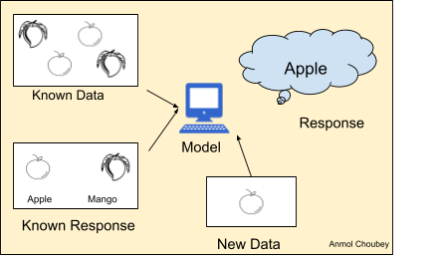

Fig 1. Supervised Learning

We have photos that are tagged as "Apple" or "Mango" in this circumstance. This known value, label, or data is put into the machine, which analyses it and learns how to associate these pictures based on characteristics like sharpness, size, and form. When a fresh unknown image is fed into the system, the machine can properly guess that it is a "Apple" based on previously given data.

Supervised Learning can be branched into two:-

* + - * Classification

Classification is applied to that dataset or model where the output variable is categorical

i.e. two or more than two. For example just like our project “PROFIT” or “LOSS”; “YES” or “NO” etc.

* + Regression

When the output variable is a real or continuous value, regression is performed to the dataset or model. The value of the target variable is determined by the values of other variables present; for example, when the temperature rises, humidity rises at the same rate, therefore the model learns to anticipate the value of humidity when the temperature rises.

## UNSUPERVISED LEARNING

Unsupervised learning is when a machine uses unlabeled data to learn on its own without any human intervention. The computer looks for patterns in unlabeled data and responds with a response based on its own pattern finding.

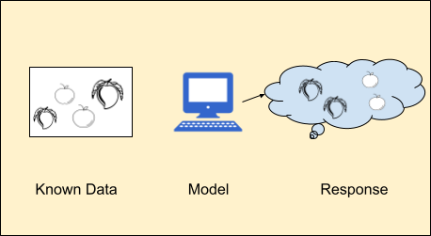

Fig 2 Unsupervised Learning

Let’s take the example similar to the previous one, but in this case, we don't feed the machine with labeled data like this is apple and this is mango. The machine itself identifies the difference in the patterns from the given set of unlabeled data and groups them based on their pattern similarity.

Unsupervised Learning can be categorized into two types:-

* + - * Clustering

Clustering is the process of arranging objects into groups that are similar to one another but not to objects in other groups. For example, determining which customers purchased identical things.

* + - * Association

The rule-based machine learning approach of association is used to determine the chance of components in a collection appearing together. For example, finding out which goods were purchased together.

## MACHINE LEARNING ALGORITHMS

## DECISION TREE

The decision tree is the most powerful and extensively used tool for classification and prediction. A decision tree is a flowchart-like tree structure in which each internal node represents an

attribute test, each branch represents the test's conclusion, and each leaf node stores a class label. Classification takes the least amount of computation in decision tree. Although it can handle both continuous and categorical data, it is not recommended for predicting the value of a continuous variable. It allows you to see the association between the variable and the target variable more clearly. If the number of categories is greater than the number of training examples available, it may yield less accuracy.

## SVM (Support Vector Machine)

The Support Vector Machine approach is designed to find a hyperplane in an N-dimensional space that unambiguously categorises data points. The amount of characteristics accessible determines the size of the hyperplane. The hyperplane is essentially a line if there are only features. The hyperplane becomes a two-dimensional plane when the number of features reaches three. Selecting the best hyper-plane for the separation is the utmost goal of the algorithm. It is highly effective when the number of input features is more. It uses a subset of training inputs in the decision-making process which are called support vectors thus less memory is utilized.

## RANDOM FOREST

Leo Breiman and Adele Cutler patented a machine learning technique called random forest, which combines the output of several decision trees to generate a single result. Its popularity arises from its ease of use and adaptability, since it can handle both classification and regression problems. Because it uses both bagging and feature randomization to produce an uncorrelated forest of decision trees, the random forest methodology is an extension of the bagging method. A fundamental difference between decision trees and random forests is that feature bagging gives a random selection of features, guaranteeing little connection among decision trees. Random forests only look at a subset of the feature splits that are accessible, whereas decision trees look at all of them.

There are many more ML algorithms available.

## CONCLUSION

With these views in mind, one can have a clearer understanding of what is going on inside a machine learning model during its training period and how different machine learning algorithms work in order to classify or compute the correct prediction. It also helps in understanding where and with which data we should consider or give priority to which machine learning algorithm since there are plenty of algorithms available and each one of them has its own characteristics so are more compatible with certain data sets. In short, knowing these theories helps in better decision-making.

###### Chapter 4

**DEEP LEARNING**

## OVERVIEW

[10]The notion of Deep Learning and Artificial Intelligence has been present for far longer than one may imagine, according to Andrew Ng, a well-known Machine Learning author. Theoretical and developmental efforts have just recently been completed. The amount of data available to society has gradually increased. It has proven challenging for individuals to handle and evaluate massive volumes of data as they have progressed from a low data state to a high data one.

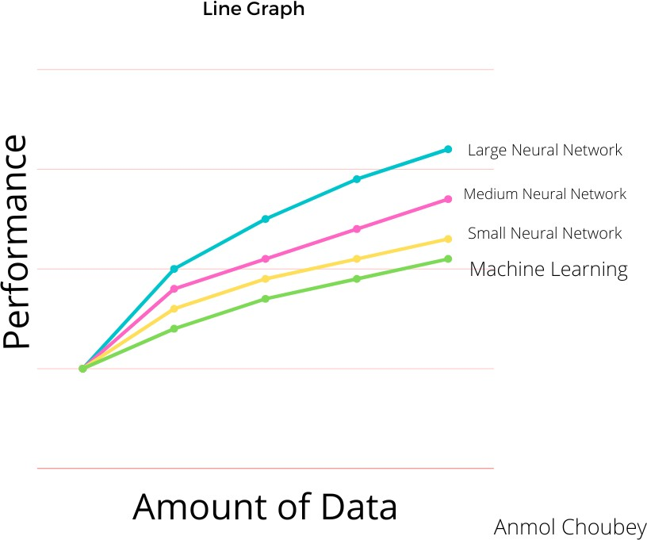

Fig 3 Neural Network Performance v/s traditional learning algorithm

Deep Learning has been gaining popularity among learners. It has progressed from theoretical academics to industrial applications and research. With continually evolving algorithms and systems for processing large amounts of data and sophisticated computations, advantages have been obtained. The discipline of deep learning is upping the bar with freshly built and optimized hardware now accessible. Deep learning architectures are being tweaked and generalized in order to advance efficiently with correct models. Deep Learning is favored above other methods, such as traditional Machine Learning algorithms since its execution scales with the amount of data.

When information increases in AI calculations, such as Support Vector Machines, Random Forest, and so on, execution levels increase. Profound Learning Neural Networks work well for my stock prediction because our dataset is large and may grow iteratively as more data gets added to it on daily basis, resulting in a boost in execution. In this segment, various different intuitions used while creating a Deep Learning algorithm and model are being discussed.

## NEURAL NETWORK

A neural network is a Deep Learning model based on how neurons and brains operate in humans. There are billions of neurons in the human nervous system, with over half a billion connections between them. The soma, also known as the nucleus of the neuron, is the most important portion of each neuron. In neurons, dendrites are the areas where input impulses are gathered, while a synapse is a connection between two neurons.

## ARTIFICIAL NEURON

Similarly, in the neural network of the brain, artificial neurons create a network termed the computer neural network. Each artificial neuron consists of weight, linear connection, and activation function. Weight defines the strength of a network connection, a linear function is a calculation that must be performed, and an activation function compares the value of a threshold value to that determined using the weighted sum of the linear function. Different combinations of linear functions and activation functions can be used. Some of the linear functions are Logistic Regression and Gradient Descent. Rectified Linear Unit and TanH function are two examples of activation functions, which are solely dependent on the problem to be solved.

## ARTIFICIAL NEURAL NETWORK

A network architecture that links the input, hidden, and output layers is known as an Artificial Neural Network (ANN). Data is stored in the input layer, then processed using stacked neurons in the hidden layers through multiple channels, and finally transported to the output layer for classification or prediction.

## ACTIVATION FUNCTION

One of the most important aspects of the Neural Network design is the Activation Function. They aid the system's problem-solving abilities by generating nonlinear functions. ReLU, TanH, and Sigmoid are some of the most prominent Activation Functions. The activation function's primary goal is to compare the hidden layer values to the threshold, as well as to allow or prevent the artificial neuron from progressing to the next hidden layer.

Activation Functions are employed in the processing of Back Propagation as well as Forward

Propagation. It assists the system in calculating the loss and error value in the forward stage, and it assists the system is using that loss parameter as a foundation to update the weights of the Neural Network in the backward stage.

## LSTM

LSTM networks are a sort of recurrent neural network that may learn order dependency in sequence prediction issues. This is a necessary characteristic in complicated problem fields such as machine translation, speech recognition, and others. Deep learning's LSTMs are a complicated topic. It might be difficult to grasp the concept of LSTMs and how terminology like bidirectional and sequence-to-sequence apply to the field.

###### Chapter 5

**SYSTEM DESIGN AND METHODOLOGY**

## OVERVIEW

This section discusses the project’s design strategies. Deep learning, machine learning, web scraping, and data mining play a big role in this endeavor. The design aspect of the project is essential for retaining potential clients. This segment will explore artifacts as they relate to the technical design of an application and the user analysis of it. Various interactions with stock market specialists and researchers led to the creation of these design artifacts.

## USE CASES

## BACKGROUND

The data for the stock prediction was prepared by downloading datasets from the NSE website as well as scraping data from different websites using python programming. Then the datasets were merged and prepared according to our needs for the project.

## USE-CASE DIAGRAM

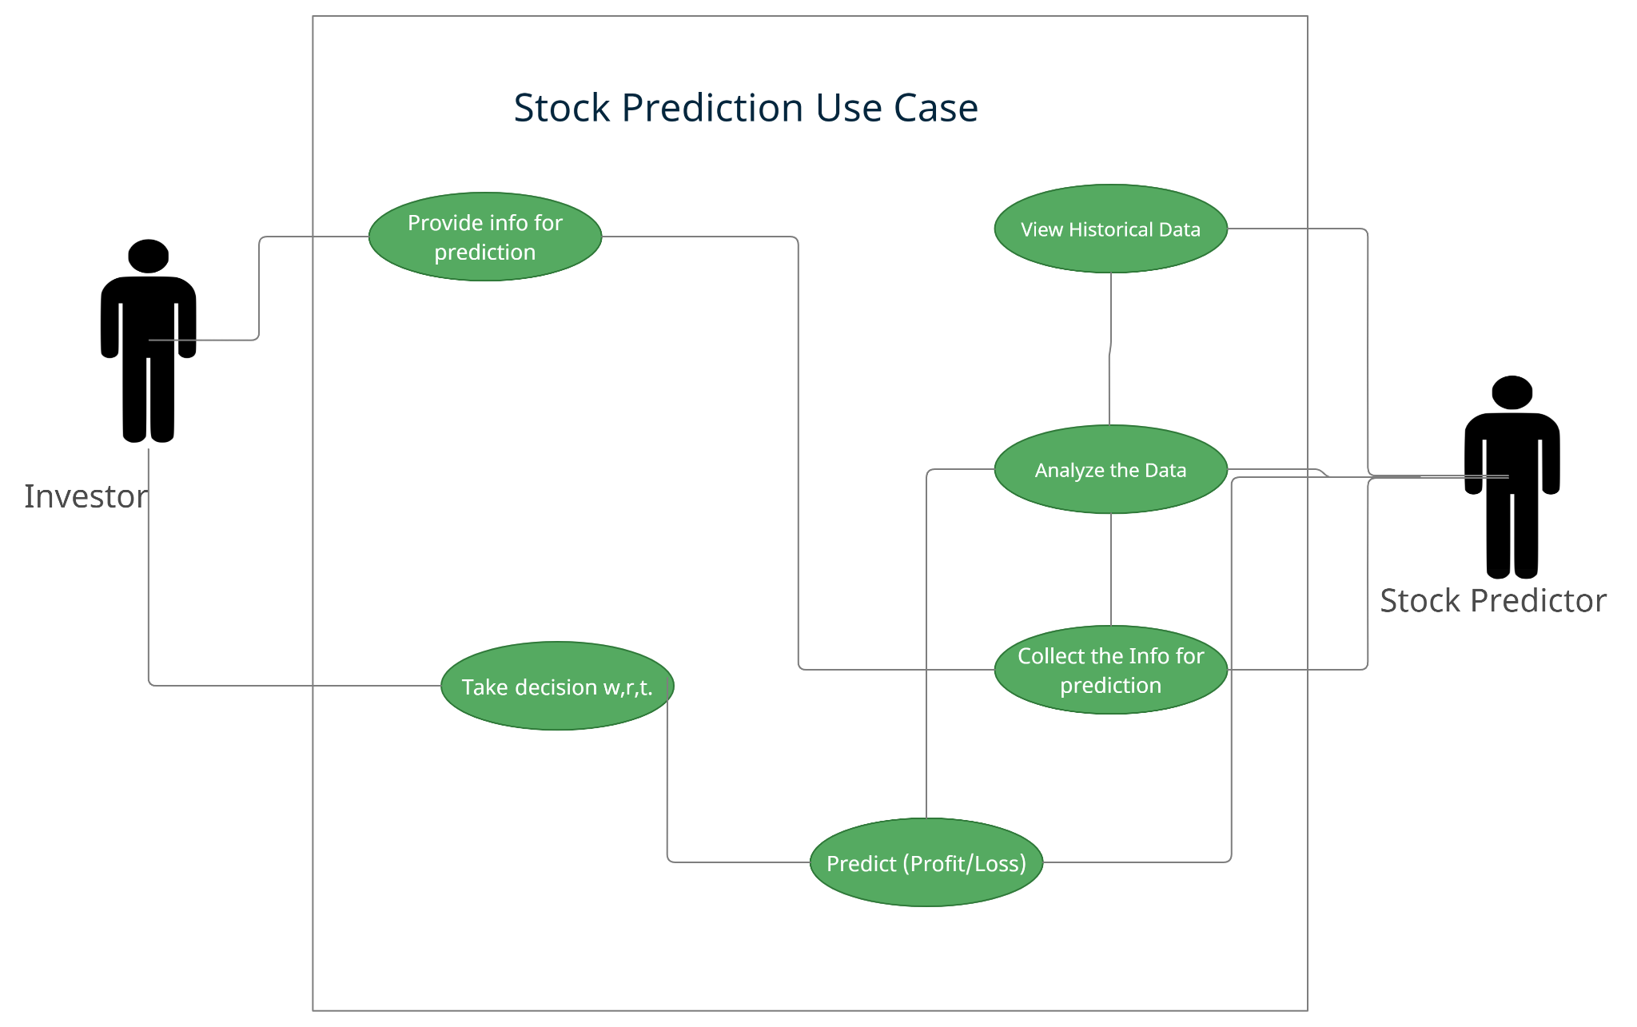

Fig 3 Use-Case Diagram

The investor provides the information regarding the stock like stock id, the number of shares bought by the promoter, market cap, %age of the market cap, and a few others then the stock predictor analyzes that data on the basis of previous historical data and current stock information. After analyzing the data it predicts whether investing in the stock is going to be a “PROFIT” or “LOSS” for the investor.

## ACTIVITY DIAGRAM

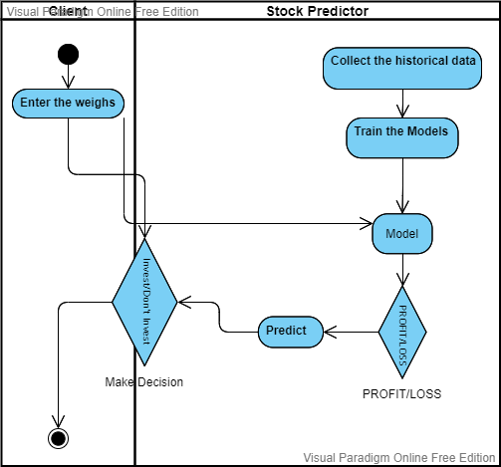

Fig 4 Activity Diagram

Figure 4 is the activity diagram for the project, according to this the client has to enter the information about the stock they are willing to invest in or if not then they have to input the previous months or previous weeks data of promoter buying then the machine will predict whether the stock is going to return a profit or loss. Or if the whole dataset is entered then it will predict the profit and loss for the same data-set.

## SYSTEM ARCHITECTURE

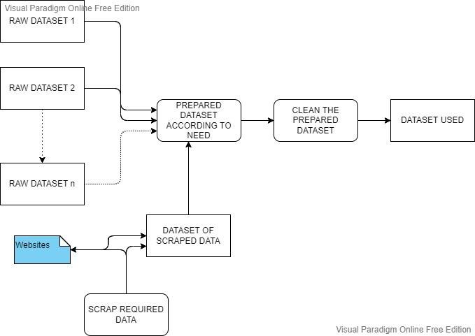

Fig 5 Preprocessing of Data

The data is collected from various websites as per our project goal in order to get better results, since the data collected was very raw, thus we processed it, and cleaned it.

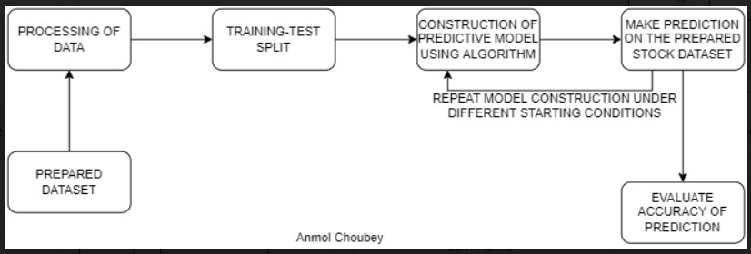

Fig 6 MODEL DEVELOPMENT ARCHITECTURE

According to figure 6, it is clear that our model development process or system for the project was very agile. We have continuously worked on the model to get the best accuracy result out of it. We prepared the data-set best suited for our project goals, and processed them accordingly to get the best out of it.

## METHODOLOGY

For the project we will move forward with the agile methodology. As it enables quick prototyping and operates in accordance with the needs of the user. In this project, Agile has aided in properly prioritizing the tasks in order of significance to ensure that the project's major goals are met. It adheres to four principles:

* Individuals and Communications above procedures and technological means.
* Operational and working software over comprehensive certification and documents.
* Close association with users and customers over contract diplomacy.
* Responding to the alterations over getting behind a fixed plan.

## CONCLUSION

This section provides an overview of the design artifacts used in this project, with these artifacts, it will be easier to identify the user and technical aspects of the project.

###### Chapter 6

**IMPLEMENTATION**

## OVERVIEW

This section of the project describes how the project will be implemented. This section consists of data preparation, data mining, and algorithm development.

## WEB SCRAPING

Web scraping played a really important role in the preparation of the data as every data was not present in a single place and since for this project we prepared our own data, thus collecting the data from different sites about the stock is really difficult if not web scraping.

Since we are predicting whether the stock is going to provide us profit in the future if we are investing in it or not we have to get a little extra information about all the stocks. Every stock registered with NSE (National Stock Exchange) has a stock code or token a unique code for them to uniquely identify them thus we need to have those in our dataset as the data which we download from the NSE site doesn’t consist it.

We collected those token names or stock codes from a site using web scraping. Matched them with the stock names and added the column to the data set.

Now, we know that any disturbance in the market affects differently for different industry types for example during the pandemic period pharma industry was on the top their stock prices were going up but travel companies' stock prices dipped too low. So having info about the data type is really important for the prediction.

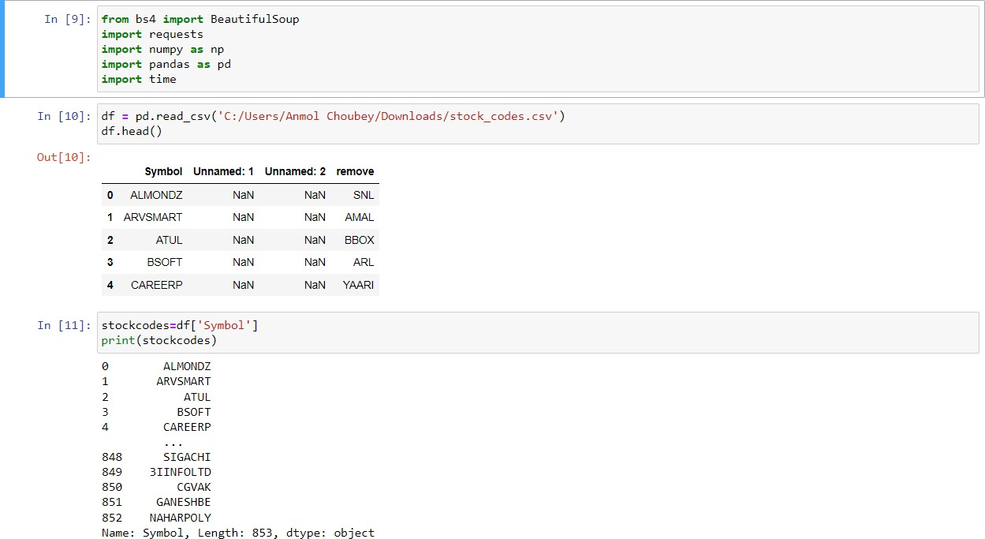

Fig 7 Web scraping code (Part 1)

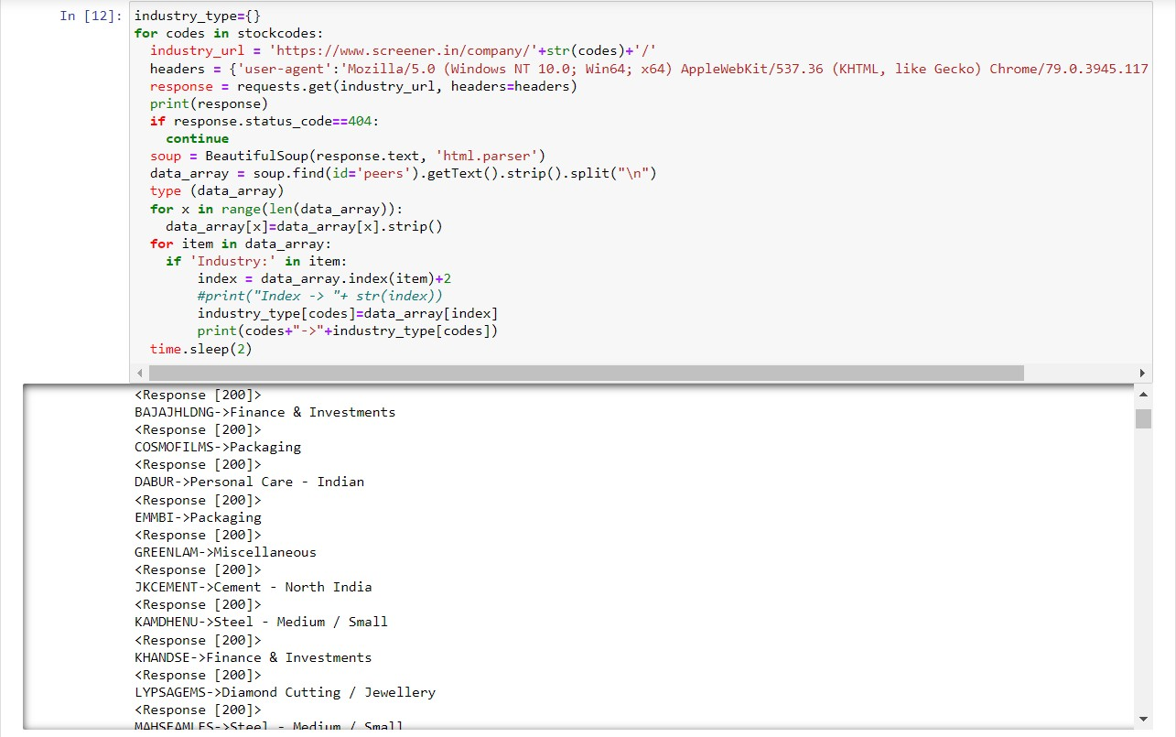

Fig 8 Industry Type scraping (Part 2)

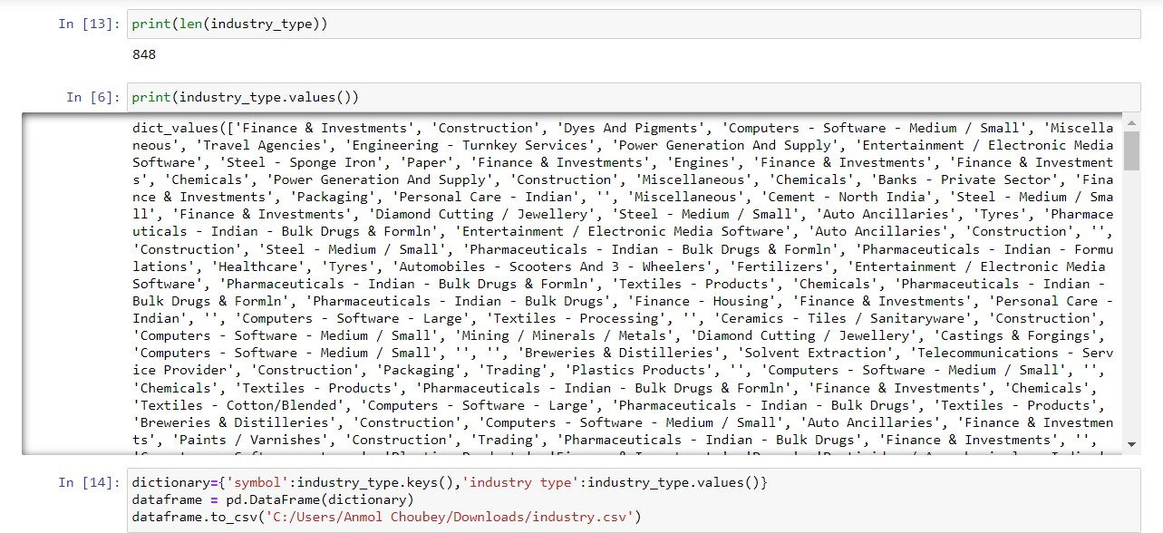

Fig 9 Saving industry type to file (Part 3)

We scraped through “[www.screener.in](http://www.screener.in/)”, one by one collected the industry type of the stocks using their stock codes or token names which are unique for everyone. After collecting the information for the industry type, it was saved to a local directory in a CSV file which consists of stock code and its respective industry type.

Further, we collected a few more information about the stocks which will help us predict with better accuracy.

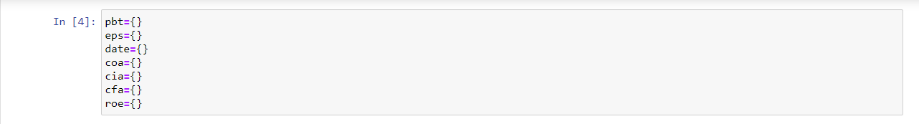

Fig 10 What we were scraping (Part 4)

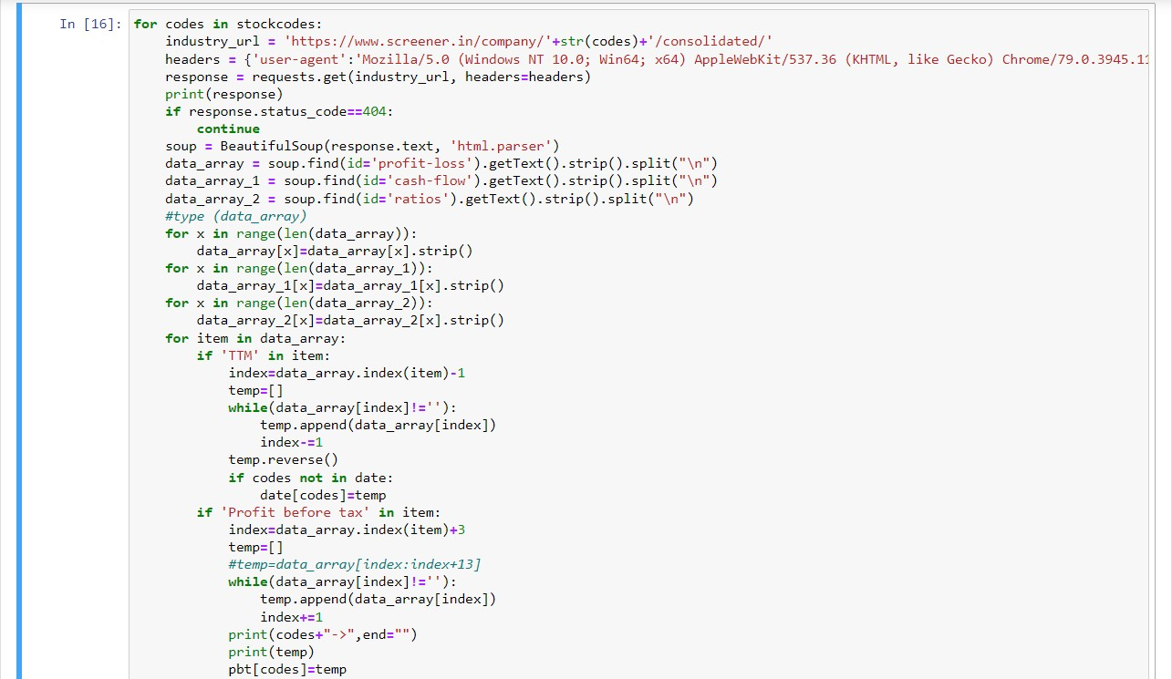

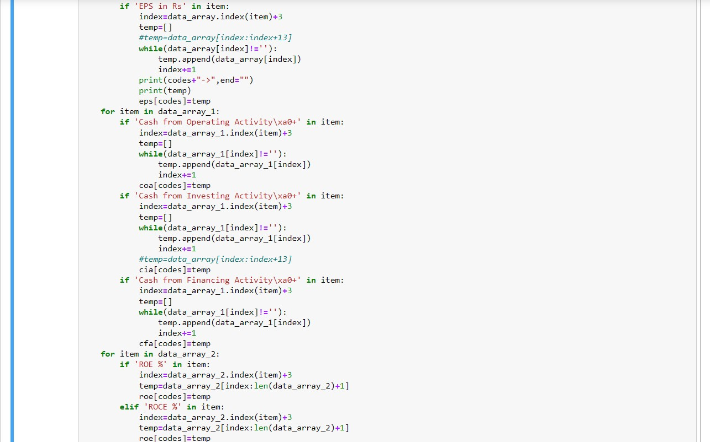

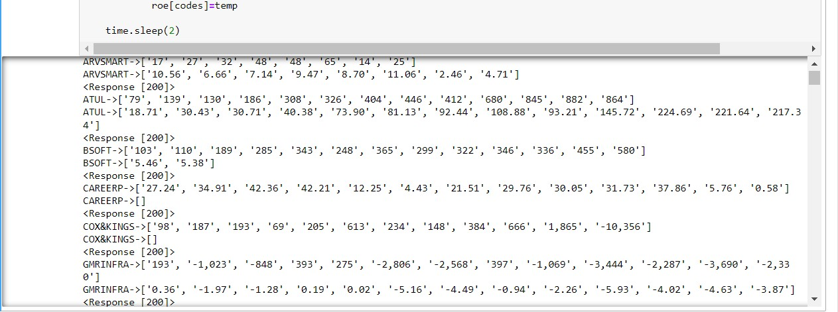

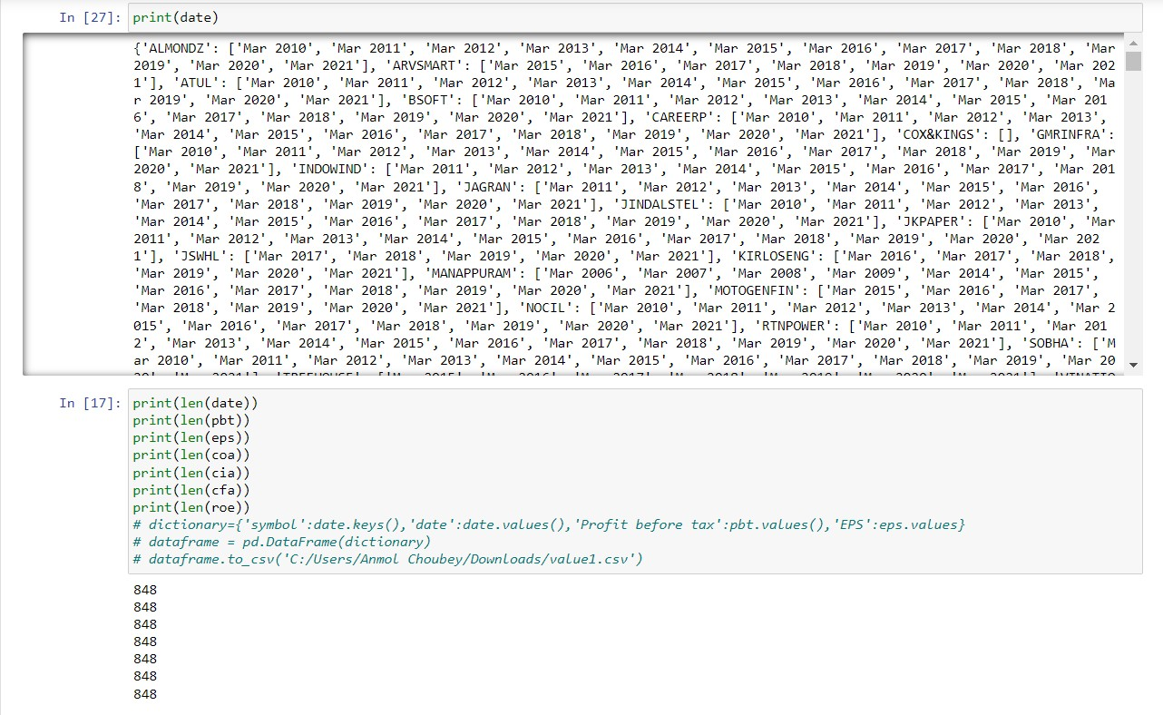

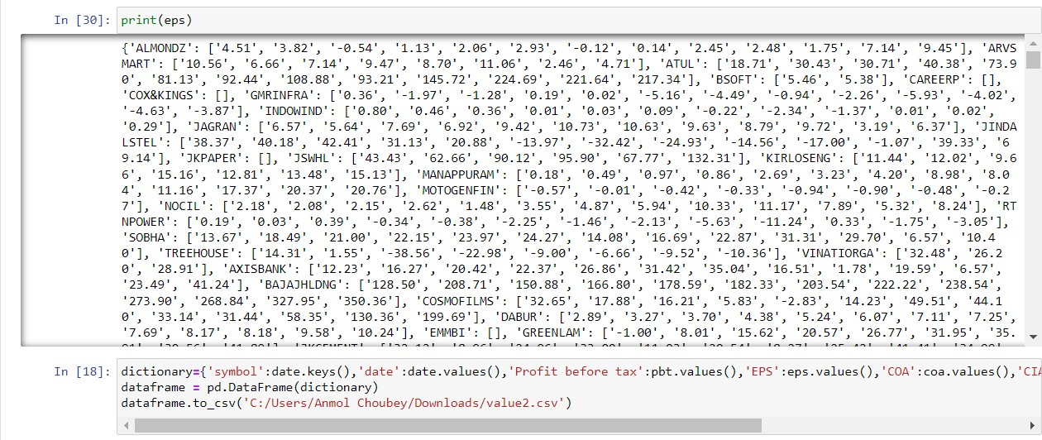

Fig 11 scraping and saving all the information (Part 5)

## DATA PREPARATION

Data preparation has a very important role in building models. The first and foremost step in this

project was extracting insider trading data. The data was extracted from the website of the NSE. The data contained historical insider trading data from the year 2015 to the year 2021. The downloaded data was insider transactions made by different types of parties during the year. It included pledge data, derivatives data, and a lot of other irrelevant data.

After downloading the data, the first step was to filter the transactions. Irrelevant transactions had to be deleted. The data filtering tool available in Excel was used to achieve this. Firstly the transactions that were made by promoters were kept. All other types of transactions were removed. Similarly, other irrelevant transactions were removed like transactions other than market purchase/sale.

Now we have the transactions that are relevant to us. The next step was to amalgamate the transactions of the same company in the same month. Pivot table function of Excel was used to do this. After adding up the transactions for the same month for the same companies, the companies that had net selling positions were removed as we are only concerned with companies that have net positive buying. The next step was a few mathematical calculations like net buying value, average buying price, etc.

The data of other attributes of the stock was also needed to be extracted. For this purpose, the Google finance function of the spreadsheet was used. Also data was extracted using web scraping. However this data needed to be placed correctly with all the entries. In order to do this various functions of Excel was used including Index, Match, Left, Char, Substitute, etc.

## MACHINE LEARNING

We all know that machine learning is an exceptional creation of humans which is making and can make human life easy. In this project, we are always this outstanding creation to help us predict which stock is going to provide us profit in the future. There are many machine learning algorithms that can be used for this but for the project we have used a few selected ones which are logistic regression, decision tree, support vector machine, random boost classifier,

k-Neighbor classifier, perceptron, and SGDclassifier.

Since, our dataset contains data of 2 months, 6 months, 9 months, and 12 months aggregation so we will use all of these machine learning algorithms one by one to all of them and try to predict. As explained above in the data preparation section that for alpha return we have taken a few Benchmarks for all these months aggregation of 5%, 10%, 13%, and 15% respectively so will have to apply these algorithms with these Benchmarks also and check the results. There is a “max” dataset that takes the results as the maximum value that prevailed in various time frames. The rationale behind this dataset is that a lot of entries are profitable in some time frames and were giving loss in the other time frames. Thus, even though the stock was profitable, it was marked as losses in some time frames and could have led to the wrong training of the model.

Thus, this dataset was prepared to train the model without this bais.

## LOGISTIC REGRESSION

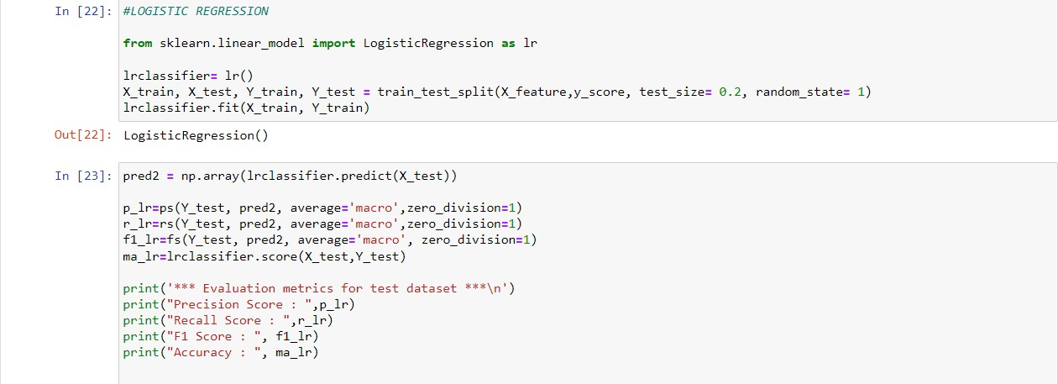

Fig 12 Code for LR

## DECISION TREE

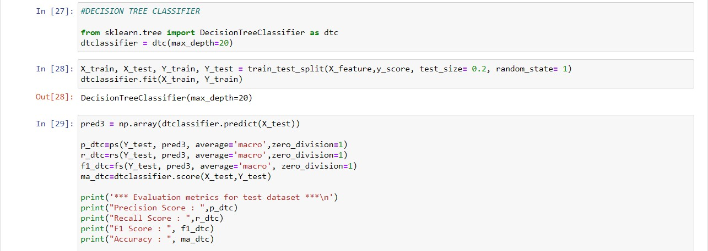

Fig 13 Code for Decision Tree

## SVM

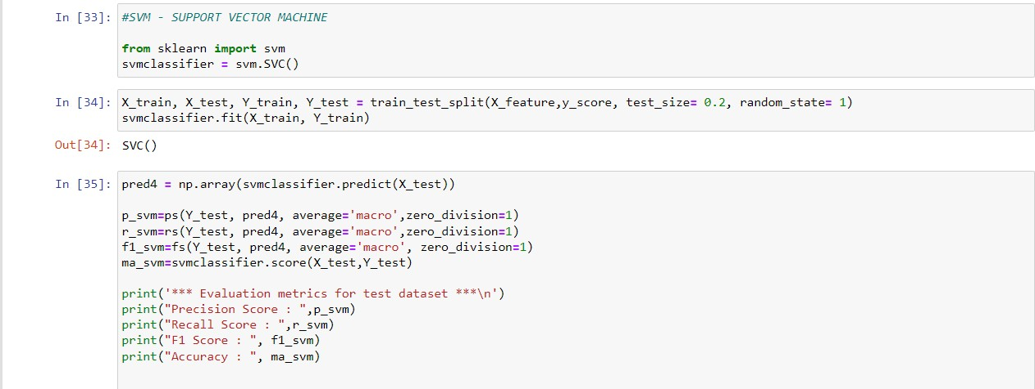

Fig 14 Code for SVM

## RANDOM BOOST CLASSIFIER

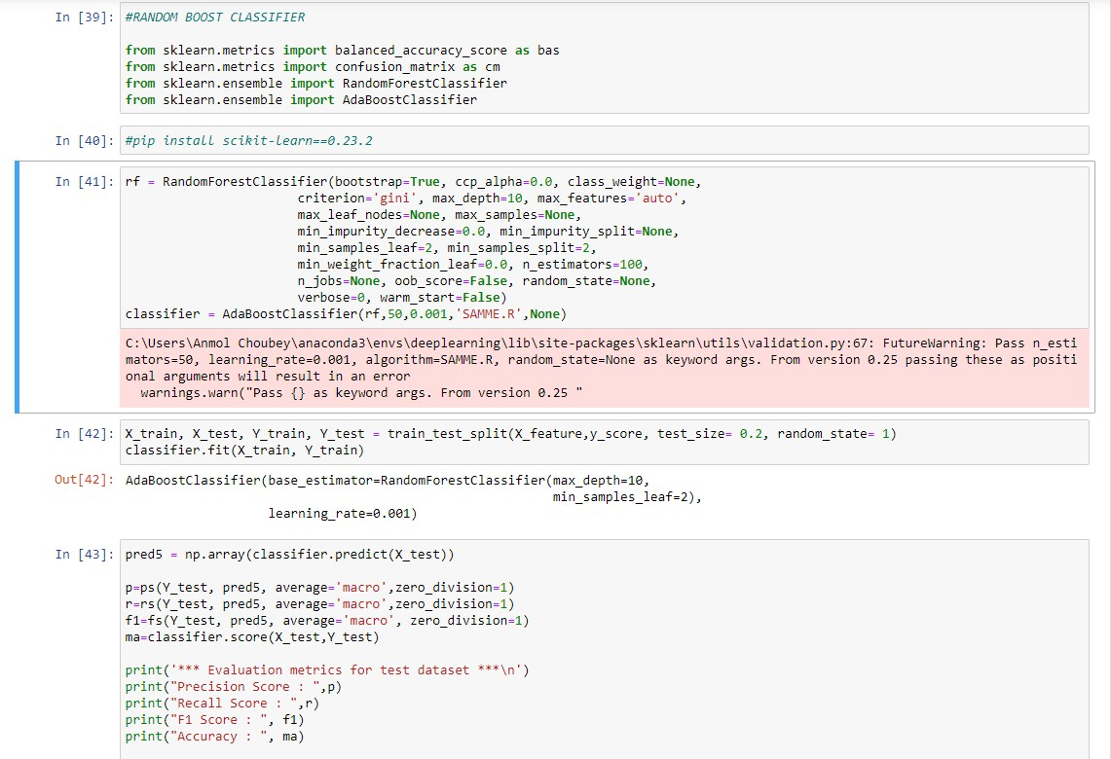



Fig 15 Code for Random Boost Classifier

## K-NEIGHBOR CLASSIFIER

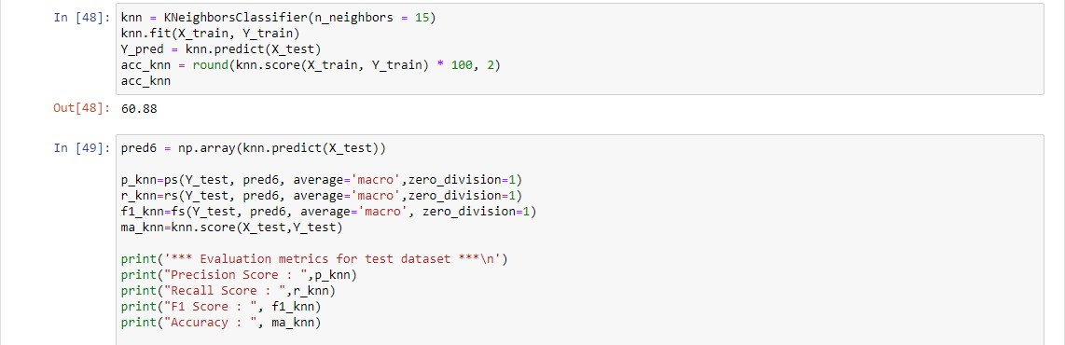

Fig 16 Code for KNN classifier

## PERCEPTRON

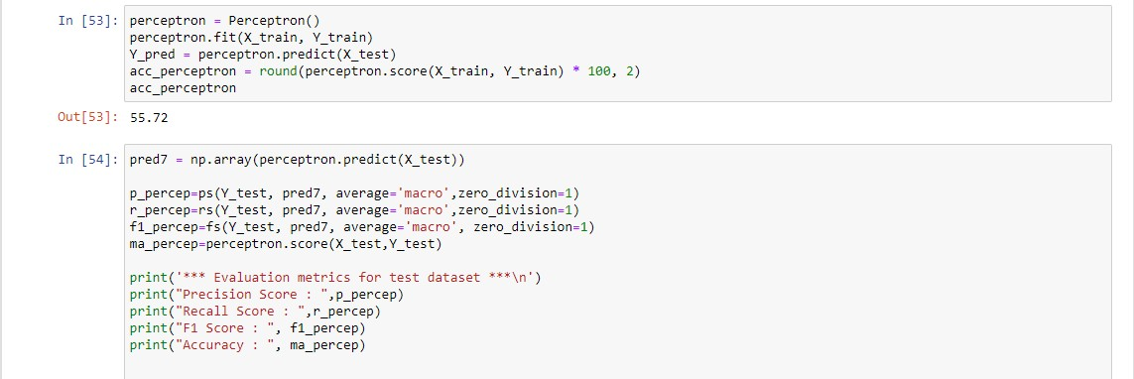

Fig 17 Code for Perceptron

## SGD CLASSIFIER

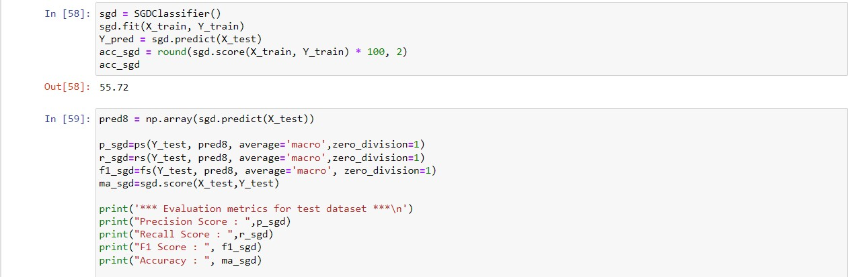

Fig 18 Code for SGD Classifier

## ACCURACY OF MACHINE LEARNING ALGORITHMS

The most important aspect of prediction is accuracy i.e., how much accuracy the algorithm is giving. On the basis of that decision-making of investing in the stocks will take place.

|  |  |  |
| --- | --- | --- |
| Algorithms | Result (Accuracy) | Result with the Benchmark (Accuracy) |
| Logistic Regression | 54.65 | 57 |
| Decision Tree | 62.77 | 63.21 |
| SVM | 56.30 | 58.77 |
| Random Boost | 63.60 | 67.25 |
| K-Neighbor | 52.88 | 56.41 |
| Perceptron | 56.41 | 41.22 |
| SGD Classifier | 56.85 | 58.30 |

Table 1 Machine Learning Algorithm 2 months holding period accuracy

|  |  |  |
| --- | --- | --- |
| Algorithms | Result (Accuracy) | Result with the Benchmark (Accuracy) |

|  |  |  |
| --- | --- | --- |
| Logistic Regression | 53.07 | 58.4 |
| Decision Tree | 70.27 | 71.00 |
| SVM | 53.85 | 58.72 |
| Random Boost | 66.95 | 76.65 |
| K-Neighbor | 53.45 | 55.89 |
| Perceptron | 53.68 | 53.31 |
| SGD Classifier | 46.92 | 49.78 |

Table 2 Machine Learning Algorithm 6 months holding period accuracy

|  |  |  |
| --- | --- | --- |
| Algorithms | Result (Accuracy) | Result with the Benchmark (Accuracy) |
| Logistic Regression | 55.34 | 54.83 |
| Decision Tree | 75.31 | 77.48 |
| SVM | 55.34 | 55.21 |
| Random Boost | 79.26 | 80.66 |
| K-Neighbor | 57.76 | 55.72 |
| Perceptron | 44.65 | 47.54 |
| SGD Classifier | 55.85 | 55.47 |

Table 3 Machine Learning Algorithm 9 months holding period accuracy

|  |  |  |
| --- | --- | --- |
| Algorithms | Result (Accuracy) | Result with the Benchmark (Accuracy) |
| Logistic Regression | 56.97 | 51.31 |
| Decision Tree | 76.18 | 76.05 |

|  |  |  |
| --- | --- | --- |
| SVM | 56.97 | 55.00 |
| Random Boost | 82.89 | 79.86 |
| K-Neighbor | 58.02 | 55.52 |
| Perceptron | 57.10 | 45.00 |
| SGD Classifier | 56.84 | 43.26 |

Table 4 Machine Learning Algorithm 12 months holding period accuracy

|  |  |
| --- | --- |
| Algorithms | Result with 15% Benchmark (Accuracy) |
| Logistic Regression | 53.32 |
| Decision Tree | 75.20 |
| SVM | 52.99 |
| Random Boost | 78.93 |
| K-Neighbor | 53.64 |
| Perceptron | 47.32 |
| SGD Classifier | 52.99 |

Table 5 Machine Learning Algorithms max (dataset) accuracy

## DEEP LEARNING ALGORITHMS

Deep Learning has been advancing in the context of popularity among the learners. Deep Learning is a preferred option because execution scales with the amount of data. Various different intuitions were used while creating the Deep Learning algorithm for our project in order to get better performance.

## ANN

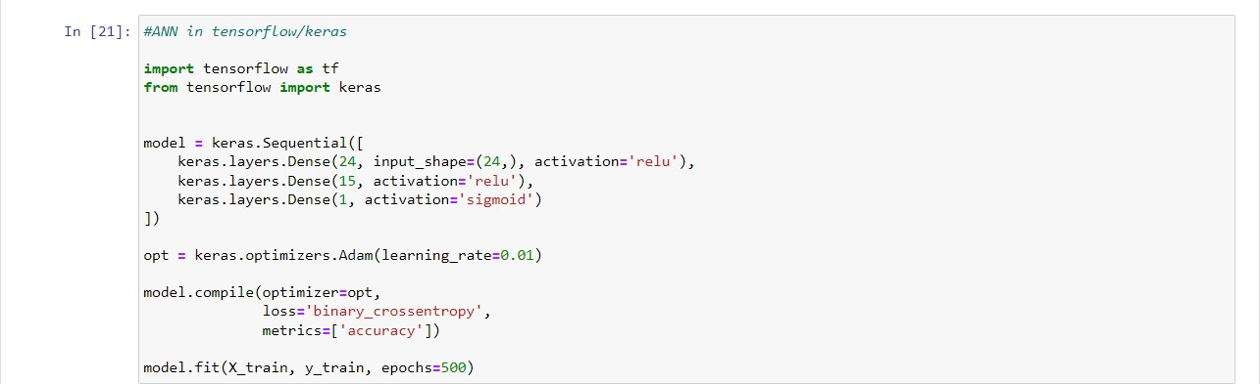

## CNN

Fig 18 ANN model code

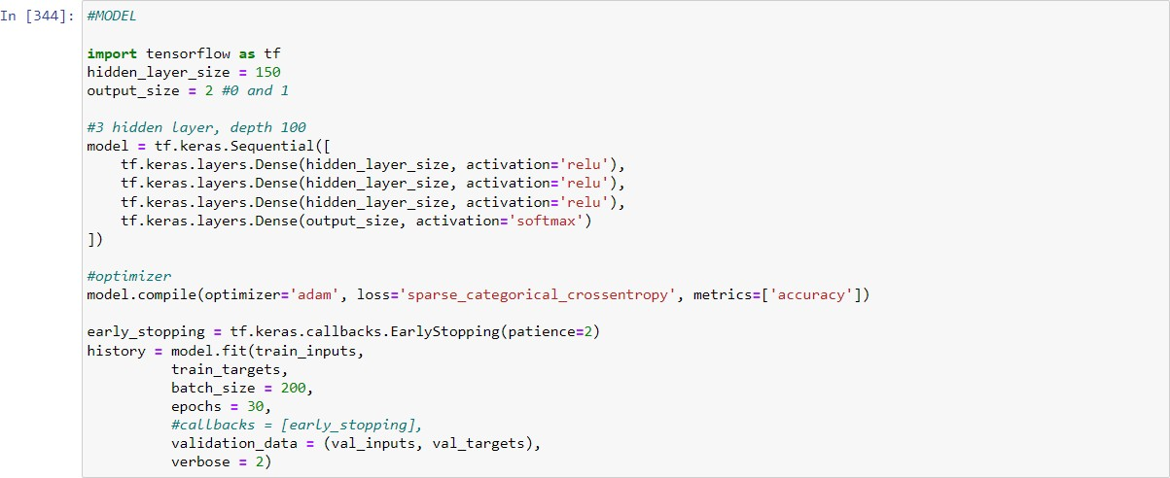

Fig 19 CNN model code

## LSTM

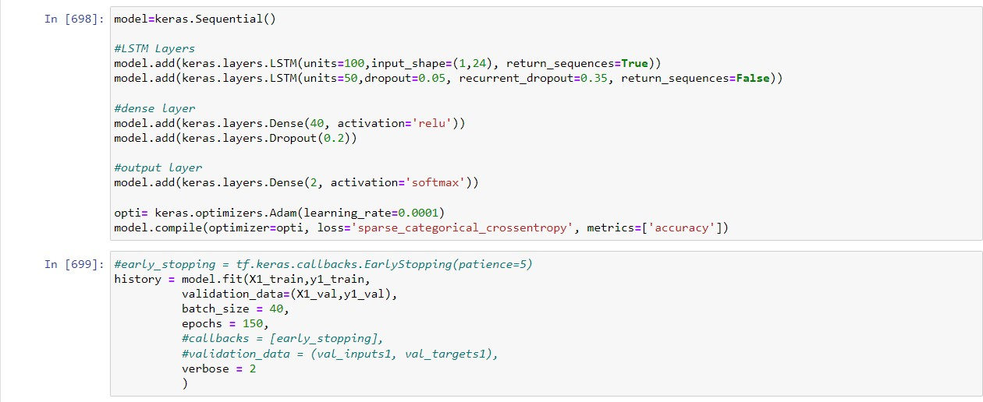

Fig 20 LSTM model code

## FULLY CONNECTED LAYER

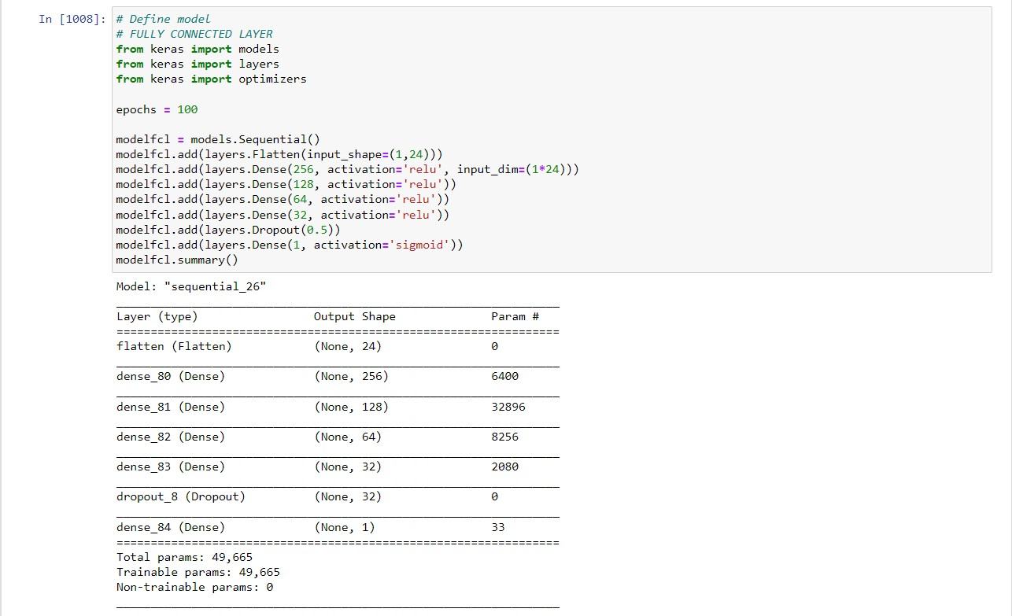

Fig 21 Fully Connected Layer model code

## ACCURACY OF DEEP LEARNING ALGORITHMS

## ANN

|  |  |  |
| --- | --- | --- |
| Months (Holding Period) | Result (Accuracy) | Result with Benchmarks (Accuracy) |
| 2 months | 70.20 | 68.56 |
| 6 months | 75.42 | 75.45 |
| 9 months | 76.08 | 78.62 |
| 12 months | 78.49 | 78.29 |
| max | 78.44 (15% Benchmark) | - |

Table 6 ANN Accuracy

## CNN

|  |  |  |
| --- | --- | --- |
| Months (Holding Period) | Result (Accuracy) | Result with Benchmarks (Accuracy) |
| 2 months | 67.61 | 68.90 |
| 6 months | 72.48 | 75.18 |
| 9 months | 78.24 | 80.03 |
| 12 months | 77.50 | 76.01 |
| max | 78.44 (15% Benchmark) | - |

Table 7 CNN Accuracy

## LSTM-RNN

|  |  |  |
| --- | --- | --- |
| Months (Holding Period) | Result (Accuracy) | Result with Benchmarks (Accuracy) |
| 2 months | 70.20 | 67.61 |
| 6 months | 72.36 | 73.83 |
| 9 months | 78.50 | 79.52 |
| 12 months | 77.11 | 78.98 |
| max | 76.01 (15% Benchmark) | - |

Table 8 LSTM Accuracy

## Fully Connected Layer

|  |  |  |
| --- | --- | --- |
| Months (Holding Period) | Result (Accuracy) | Result with Benchmarks (Accuracy) |
| 2 months | 65.14 | 65.02 |
| 6 months | 73.34 | 75.92 |
| 9 months | 78.63 | 78.88 |
| 12 months | 76.18 | 77.37 |
| max | 76.99 (15% Benchmark) | - |

Table 9 FCL Accuracy

###### Chapter 7

**CONCLUSION**

## INTRODUCTION

This chapter will discuss the model's results, outcomes, and future work to develop in the project.

## RESULTS

The results which we got in our project are appreciable, we were able to give answers to all the project goals that we had set before starting the project. We were able to create machine learning and deep learning models that were able to help us in making the decision in the investment.

They were able to predict which stocks to buy which different accuracy as mentioned in the above tables (Table 1-9). One of our project goals was to check whether using promoter buying (insider data) is able to create a successful portfolio. The answer is “yes” we are able to create that using this project below tables are the average return percentage that one would have received if they had used these models for prediction (trades of 5 months are averaged)

We have calculated the results also after creating a benchmark for different time frames. The purpose of the model is to maximize the return of the portfolio. If we create a portfolio after assigning a benchmark, the return of the portfolio tends to increase in each case. Thus, including a benchmark has a positive impact on the results.

It is visible through the tables (Table 1-13) that all the algorithms are performing really well except Logistic Regression, Perceptron, K-Neighbors, and SGD classifier, but their performance is not as comparable to other algorithms. Decision tree and Random Boost has performed really good but gradually the amount of input data will increase so it will become difficult for decision tree to predict with better accuracy. Approximately all the deep learning algorithms have performed all most same but out of all of them FULLY CONNECTED LAYER has performed the best as it has given better accuracy and highest return in all the holding time period.

|  |  |  |
| --- | --- | --- |
| Algorithms | Return | Return with Benchmark 5% |
| FCL | 18.12 | 19.49 |
| LSTM | 11.94 | 15.61 |

|  |  |  |
| --- | --- | --- |
| CNN | 13.83 | 21.05 |
| ANN | 13.18 | 15.66 |
| DECISION TREE | 12.22 | 22.14 |
| RANDOM BOOST CLASSIFIER | 11.28 | 23.93 |

##### Table 10 - 2 month holding period Return percentage

|  |  |  |
| --- | --- | --- |
| Algorithms | Return | Return with Benchmark 10% |
| FCL | 55.93 | 65.48 |
| LSTM | 49.45 | 50.52 |
| CNN | 49.73 | 57.07 |
| ANN | 51.62 | 50.72 |
| DECISION TREE | 51.29 | 62.25 |
| RANDOM BOOST CLASSIFIER | 38.66 | 61.19 |

##### Table 11 - 6 month holding period Return percentage

|  |  |  |
| --- | --- | --- |
| Algorithms | Return | Return with Benchmark 13% |
| FCL | 71.50 | 81.71 |
| LSTM | 68.60 | 73.09 |
| CNN | 70.62 | 77.38 |
| ANN | 69.28 | 74.68 |
| DECISION TREE | 78.00 | 91.20 |

|  |  |  |
| --- | --- | --- |
| RANDOM BOOST CLASSIFIER | 71.04 | 82.13 |

##### Table 12 - 9 month holding period Return percentage

|  |  |  |
| --- | --- | --- |
| Algorithms | Return | Return with Benchmark 15% |
| FCL | 123.07 | 123.85 |
| LSTM | 111.63 | 115.89 |
| CNN | 111.85 | 123.18 |
| ANN | 116.96 | 119.91 |
| DECISION TREE | 117.44 | 120.78 |
| RANDOM BOOST CLASSIFIER | 117.44 | 131.08 |

##### Table 13 - 12 month holding period Return percentage

## FUTURE WORKS

Models are an attempt to replicate real-life situations in numbers and try to predict the future. Thus models can't be correct but can come closer and closer to being correct. This can be done by working on improving the model, training it regularly, and researching new insights.

Similarly, this model also needs to be further shaped to bring it closer to correct. The future works required to do so include the following.

The benchmark used to predict the returns can be twisted to come up with the best suitable benchmark for each time period. The goal should not be to increase the accuracy of the model but to increase the returns of the model.

We should find other attributes of stock that have a positive correlation with profits when there is a promoter buying in the stock.

Currently, the results are calculated by the price of stocks on the first trading day of the buying month and 1st trading day of the selling month. The results can be enhanced by including technical analysis in deciding when to enter and exit a trade. This will give a possibility to buy at lower prices and sell at higher prices and thus increase return. This can also increase the

accuracy of the model as the training of the model will be more precise.

# REFERENCES

1. Naik, N., Mohan, B.R. Intraday Stock Prediction Based on Deep Neural Network. Natl. Acad. Sci. Lett. 43, 241–246 (2020).
2. Pang, X., Zhou, Y., Wang, P. et al. An innovative neural network approach for stock market prediction. J Supercomput 76, 2098–2118 (2020).
3. Kohli P.P.S., Zargar S., Arora S., Gupta P. (2019) Stock Prediction Using Machine Learning Algorithms. In: Malik H., Srivastava S., Sood Y., Ahmad A. (eds) Applications of Artificial Intelligence Techniques in Engineering. Advances in Intelligent Systems and Computing, vol 698. Springer, Singapore.
4. Ye, Q. and Wei, L. (2015) The Prediction of Stock Price Based on Improved Wavelet Neural Network. Open Journal of Applied Sciences, 5, 115-120.
5. Kolasani, S. and Assaf, R. (2020) Predicting Stock Movement Using Sentiment Analysis of Twitter Feed with Neural Networks. Journal of Data Analysis and Information Processing, 8, 309-319.
6. Keras URL https://keras.io/
7. TensorFlow URL <https://www.tensorflow.org/tutorials>
8. Safer, A.M., The application of neural networks to predict abnormal stock returns using insider trading data. Applied Stochastic Models in Business and Industry, 18(4), pp.381-389.
9. Sadia, K.H., Sharma, A., Paul, A., Padhi, S. and Sanyal, S., 2019. Stock market prediction using machine learning algorithms. Int. J. Eng. Adv. Technol, 8(4), pp.25-31.
10. Deep Learning URL <https://www.deeplearning.ai/>
11. Kuhn, Max and Johnson, Kjell. Applied Predictive Modeling. Springer. 2013
12. Lakonishok, Josef, and Inmoo Lee, 2001, Are insider trades informative? Review of Financial Studies 14, 79-111.

**APPENDIX I**

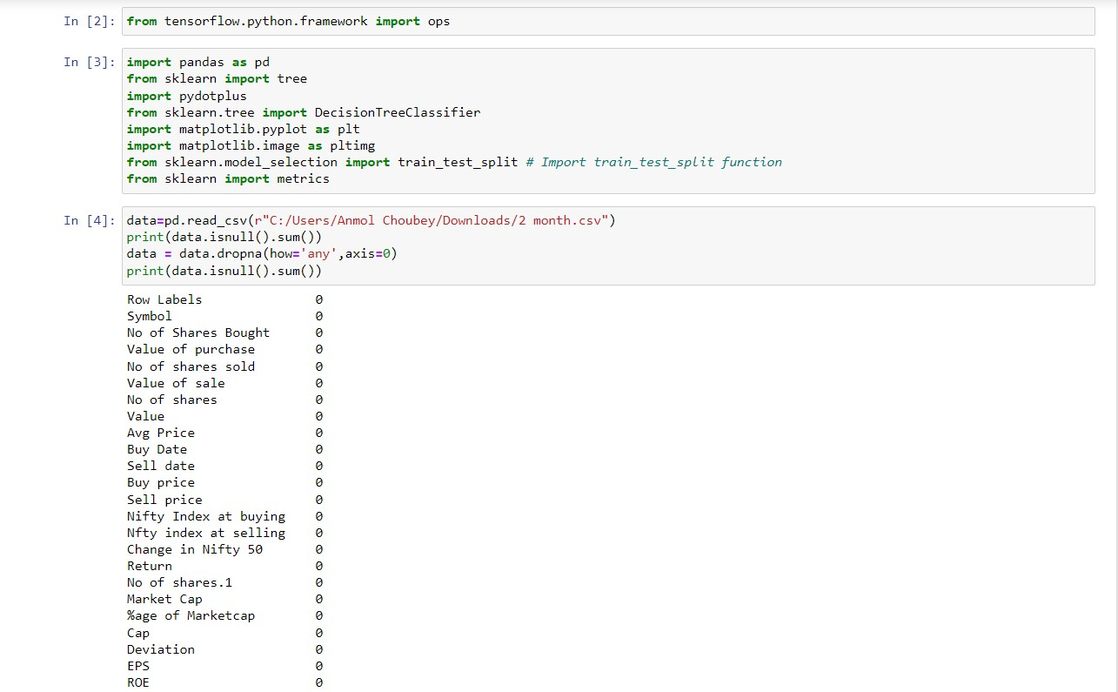



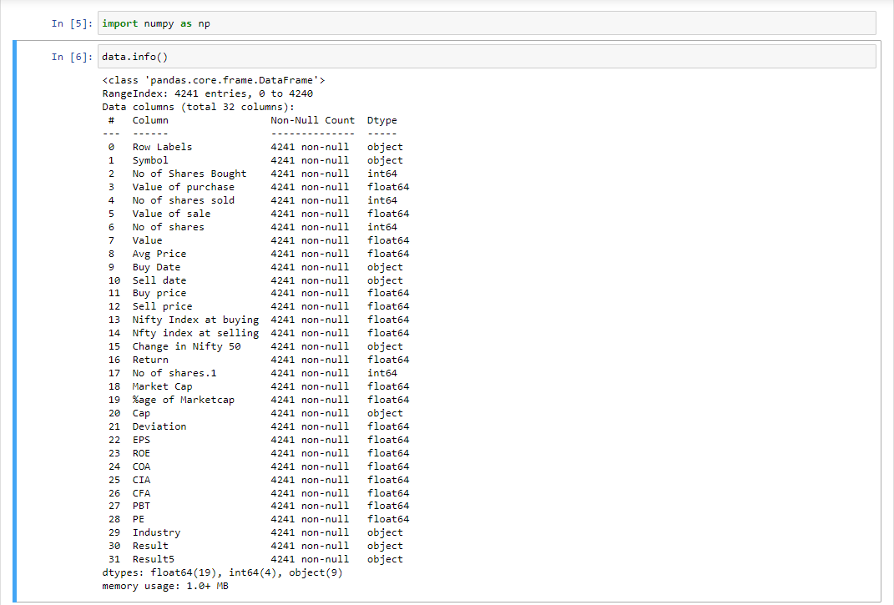

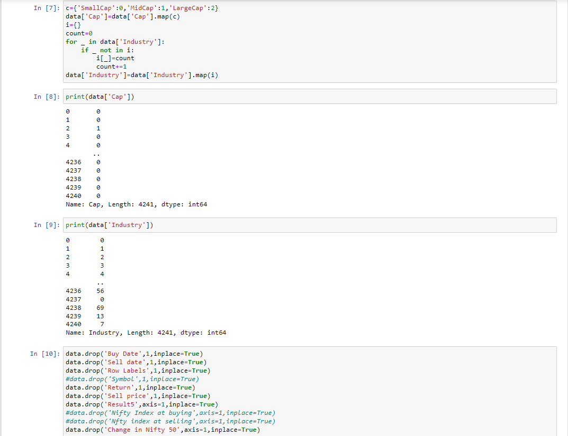

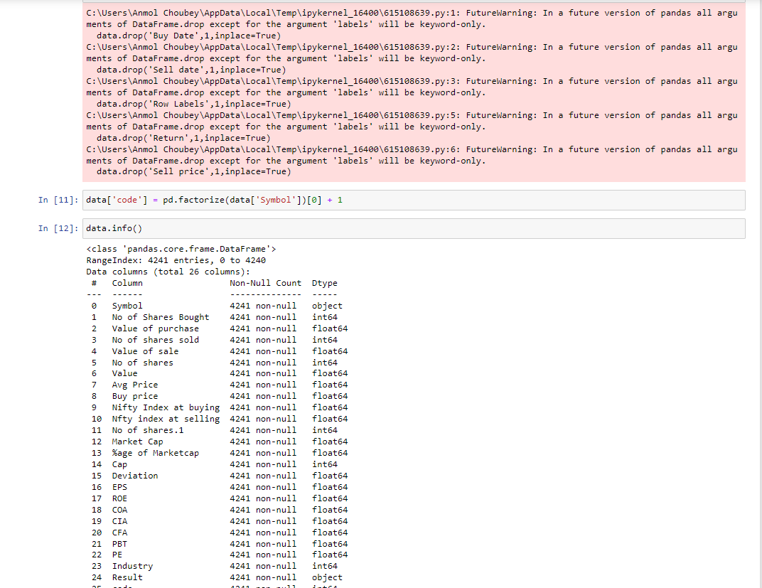

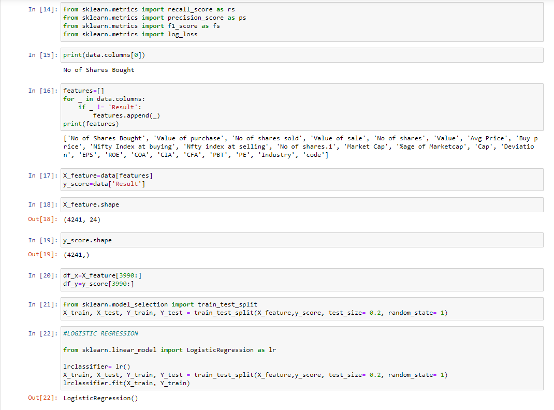

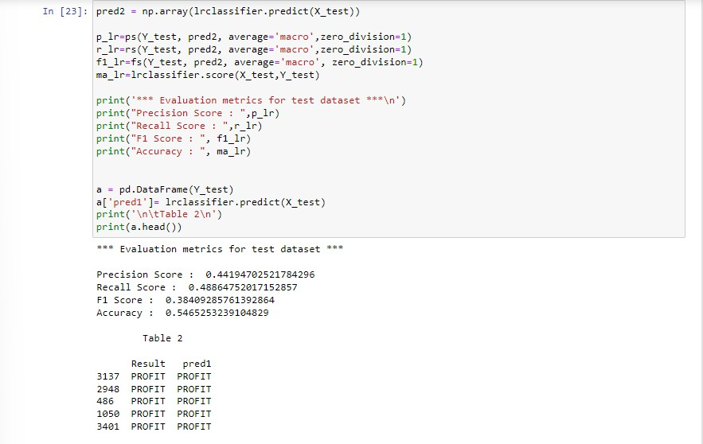

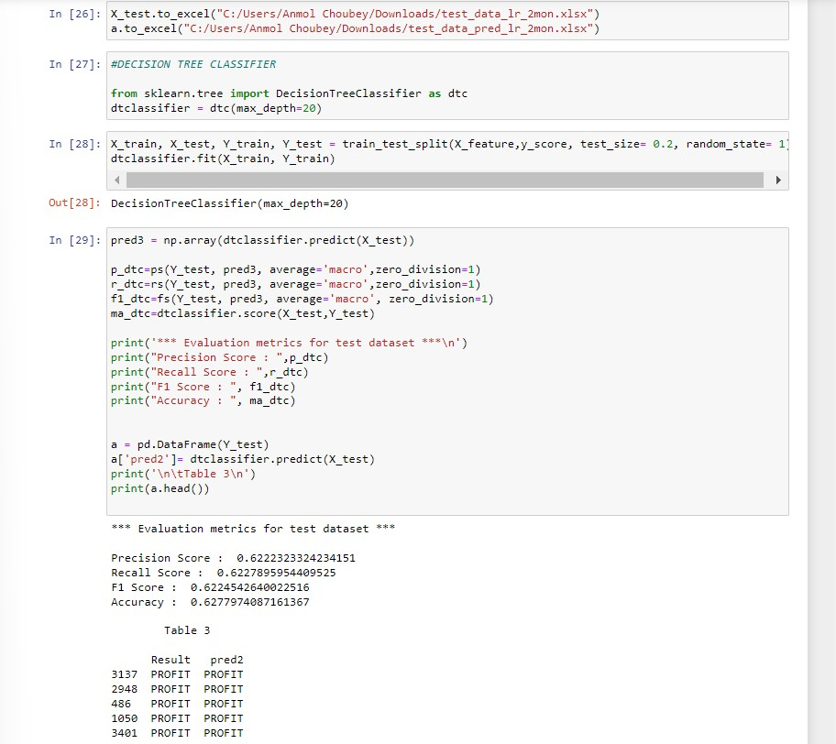

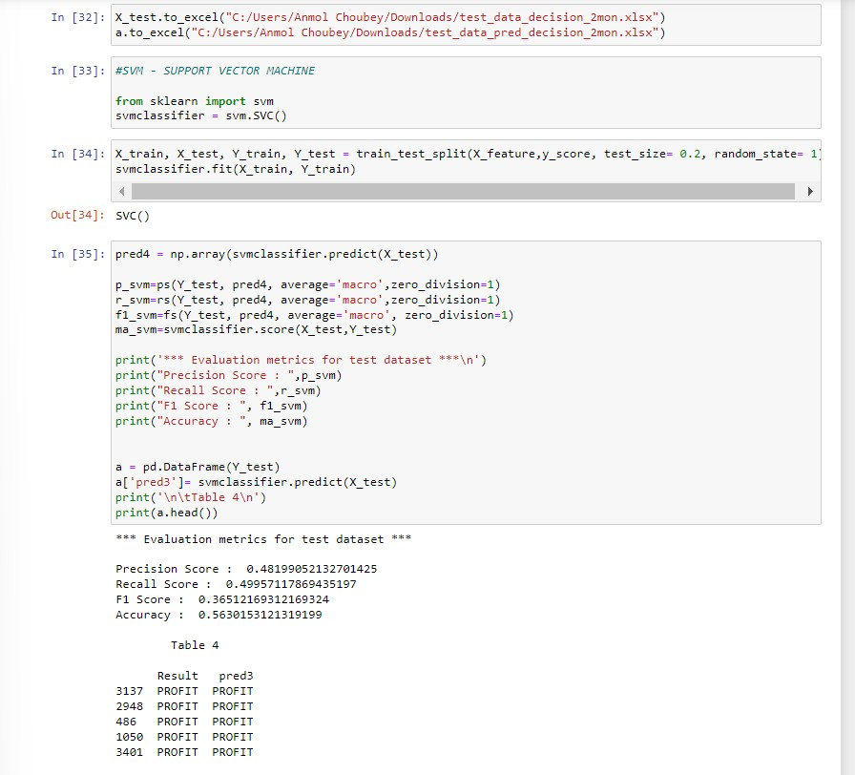

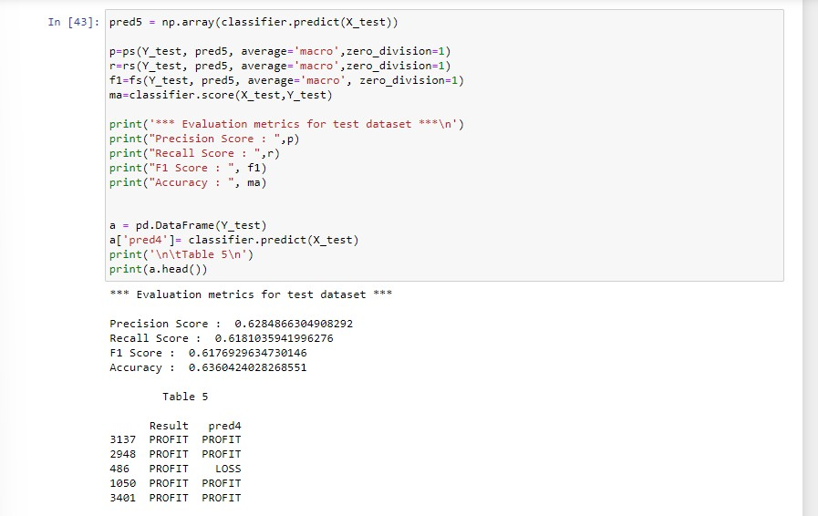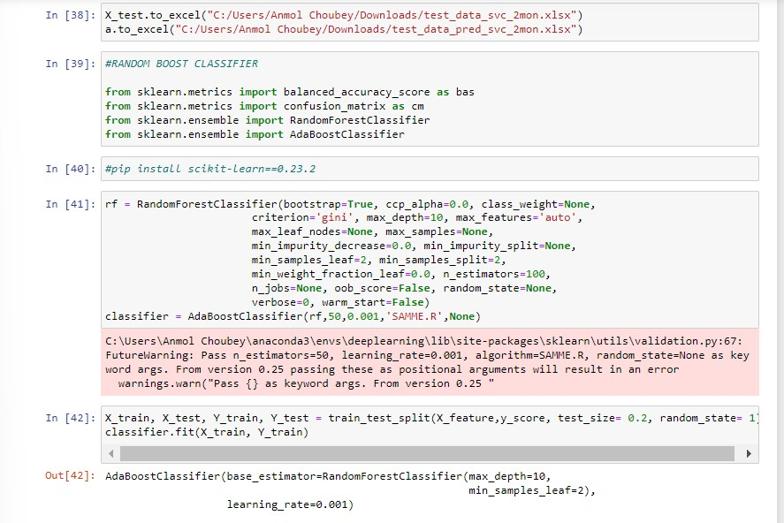

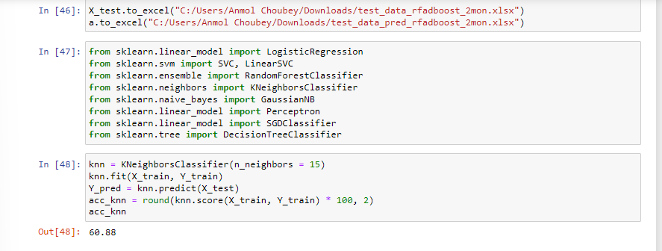

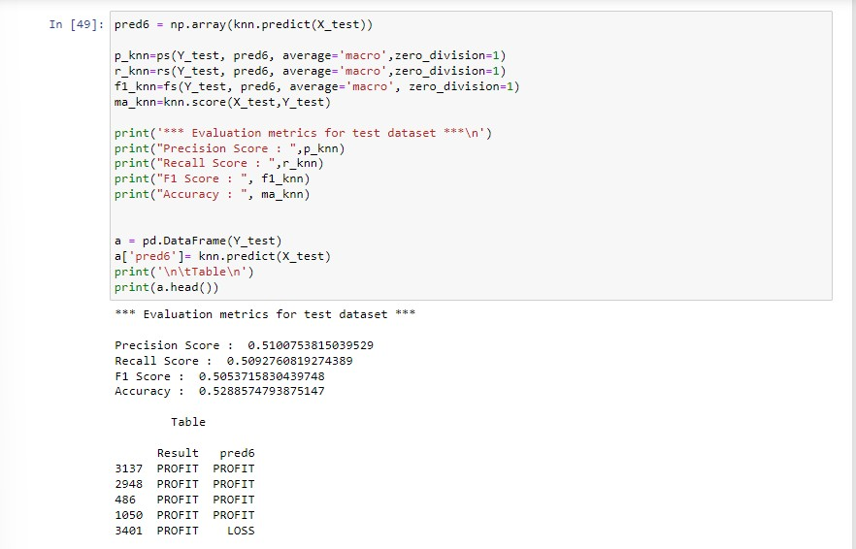

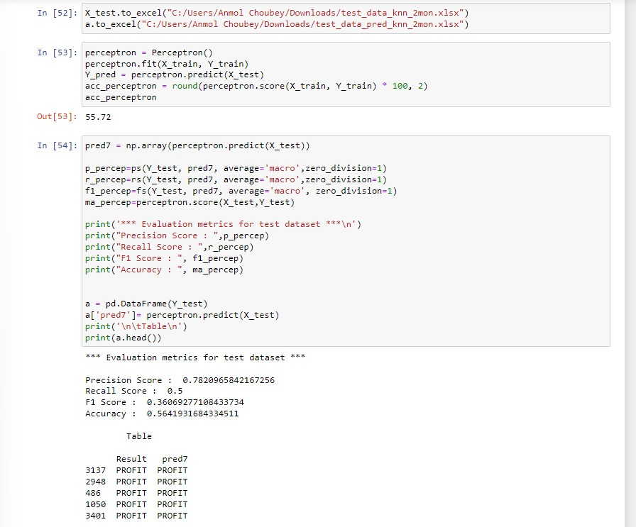

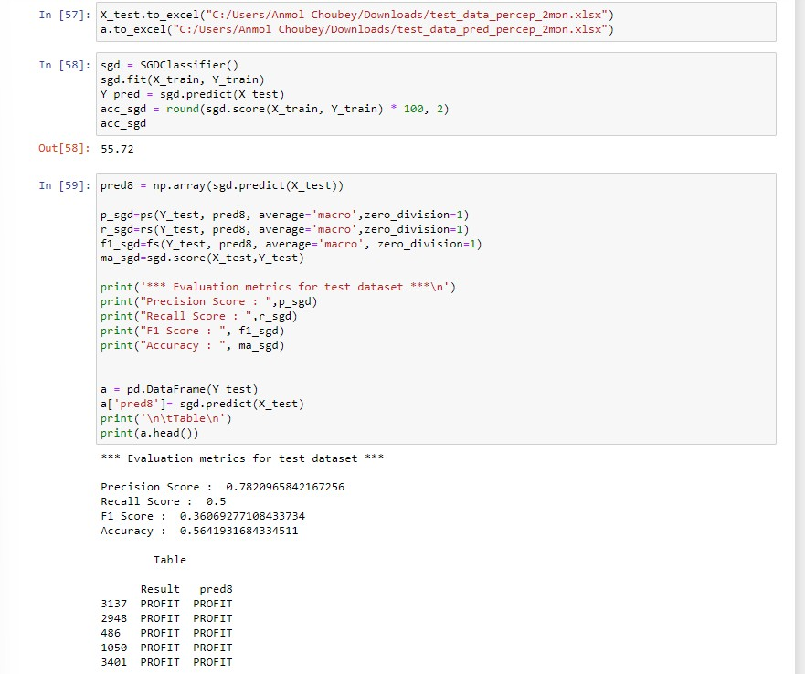

## Code for machine learning algorithms link for all the month data set and their respective Benchmarks.

**APPENDIX II**

**DEEP LEARNING**

* + **ANN**

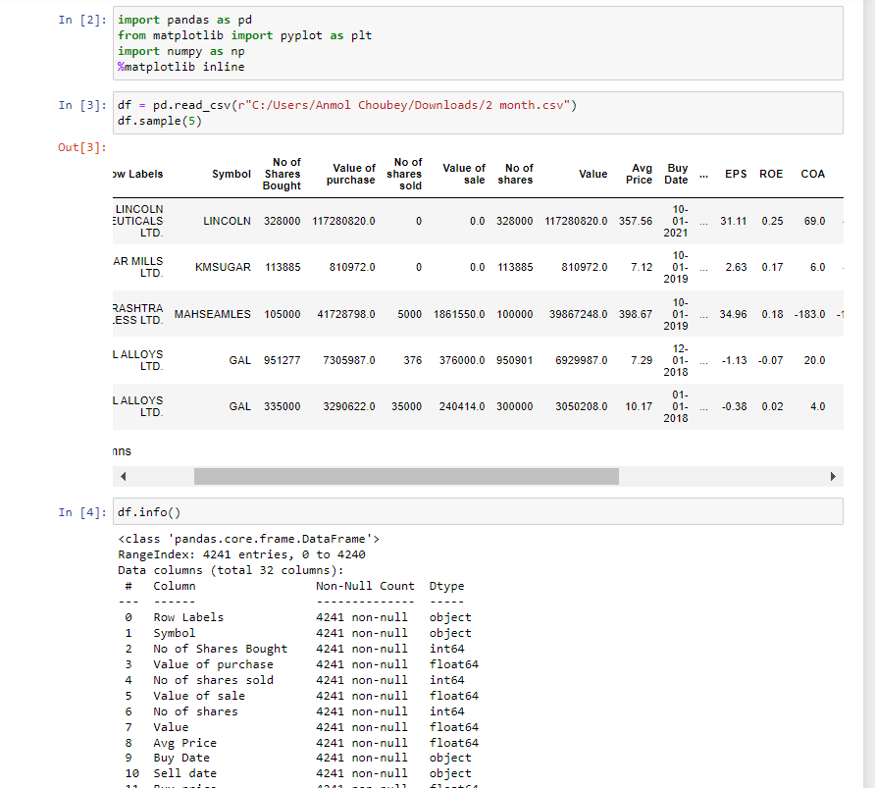

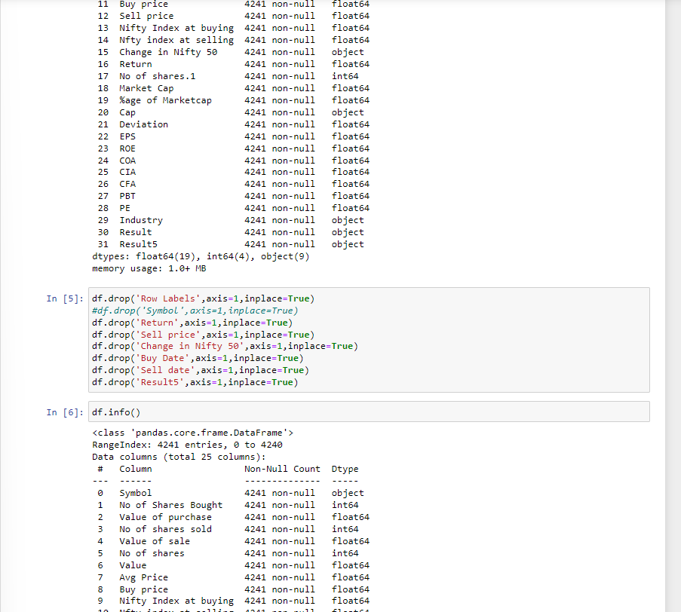

* + **CNN**

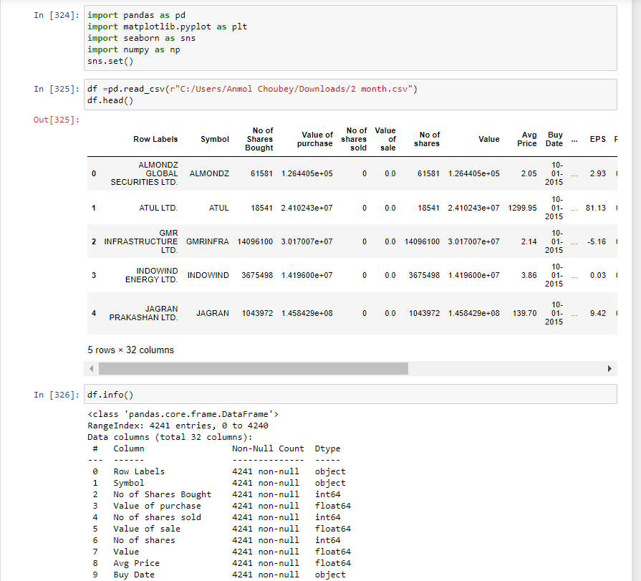

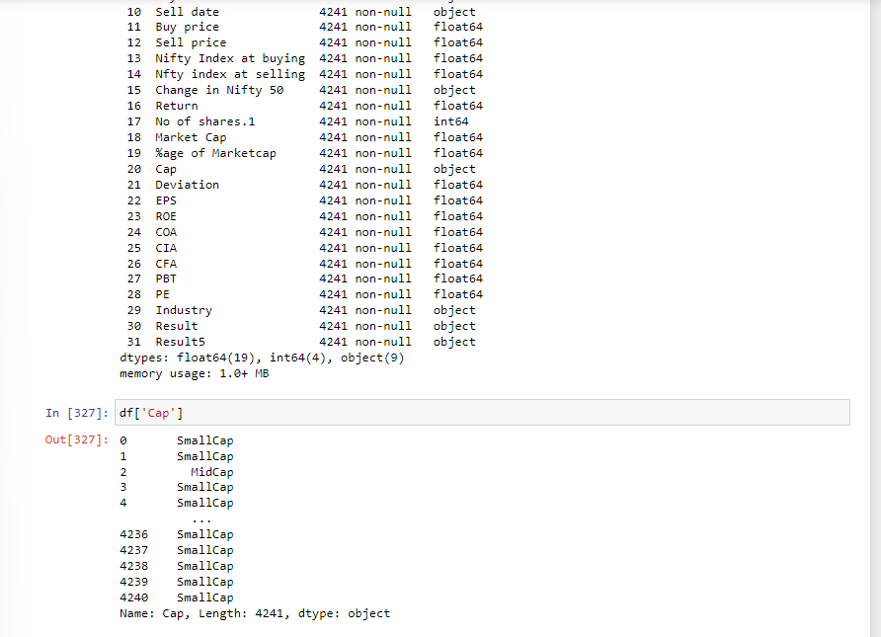

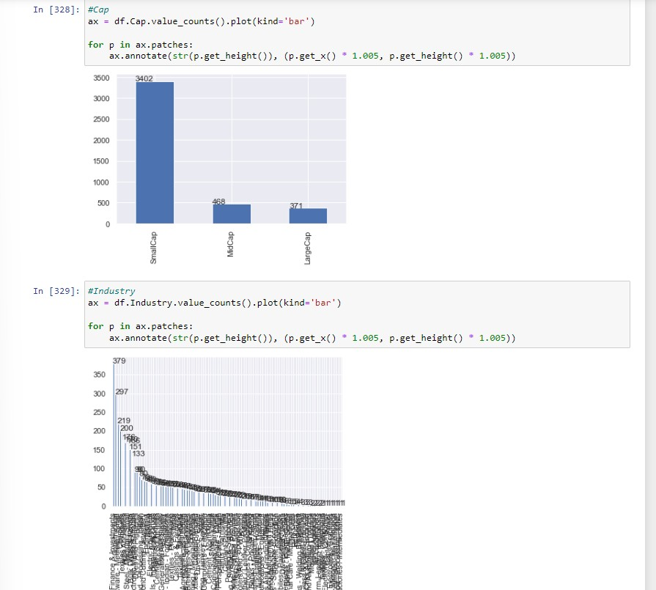

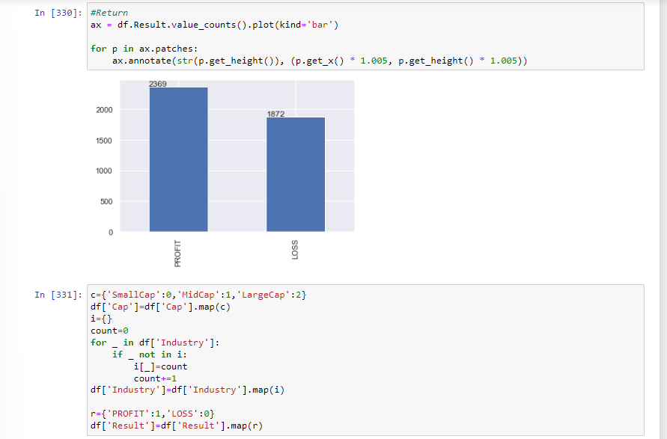

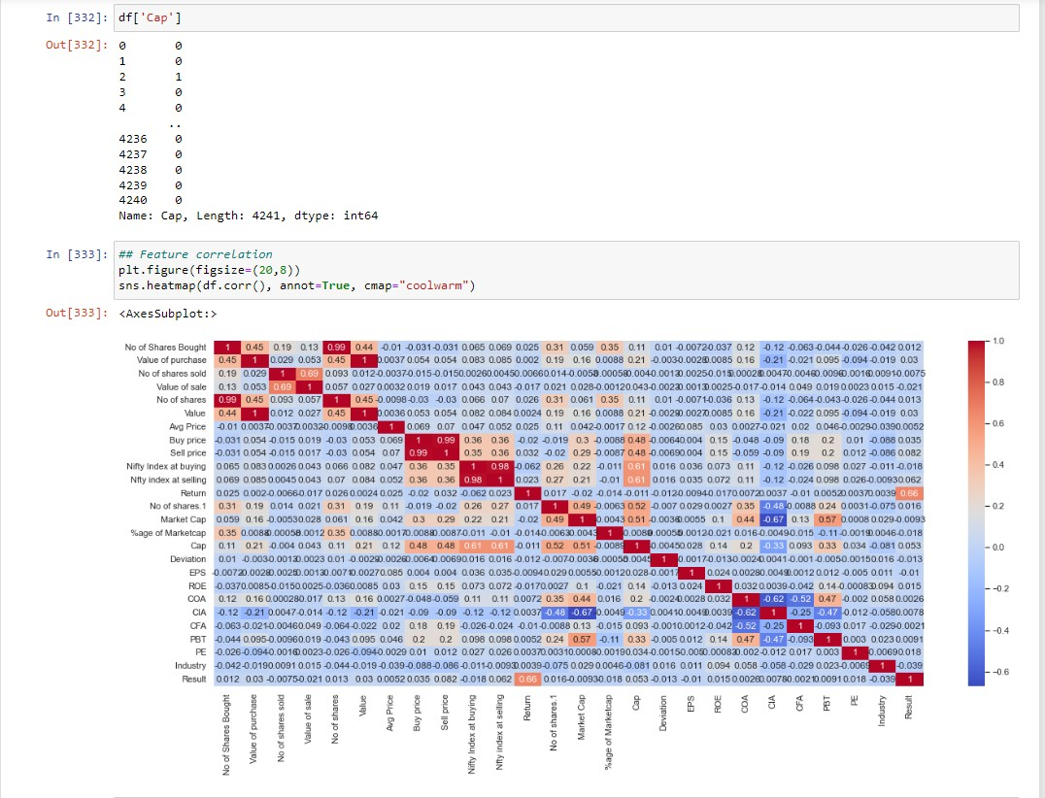

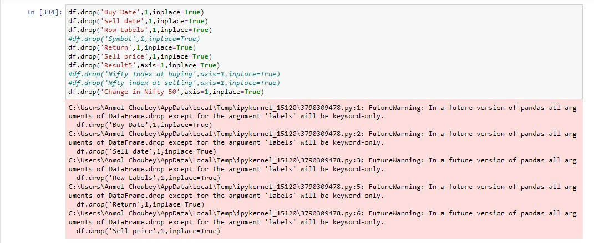

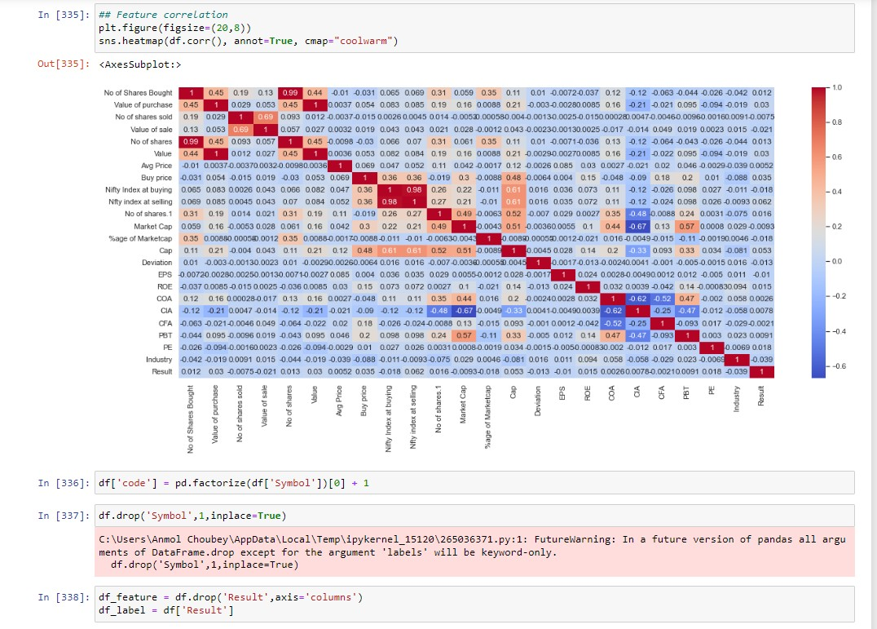

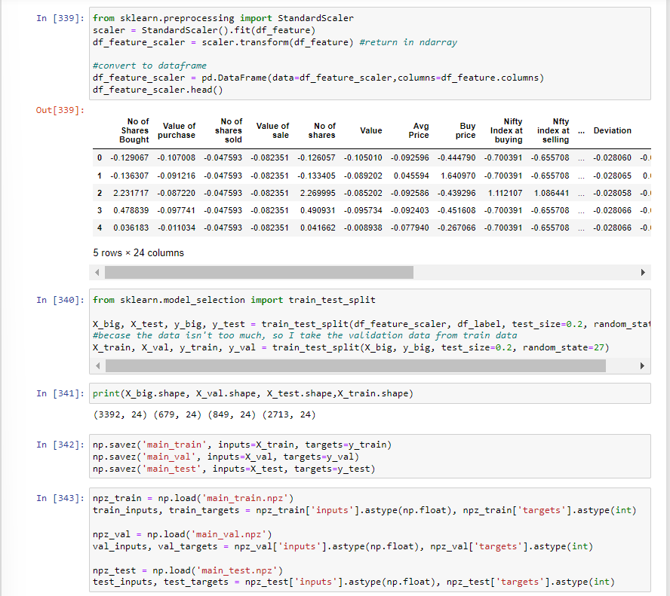

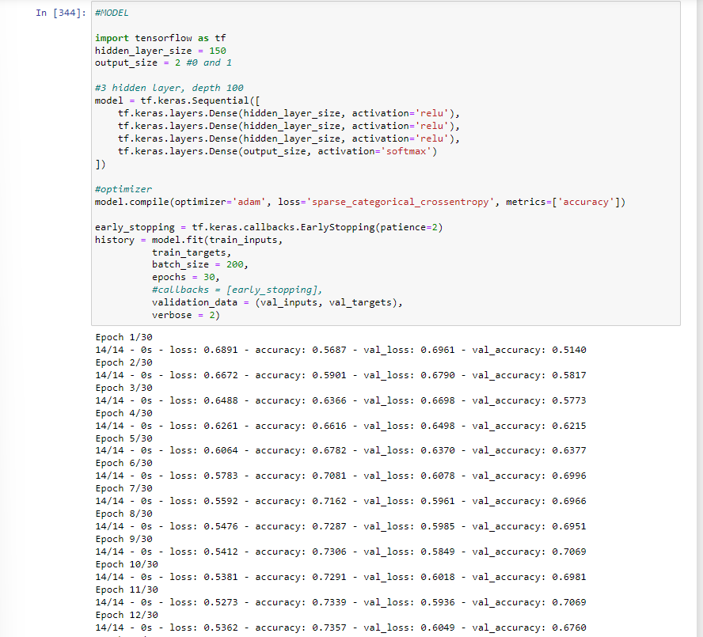

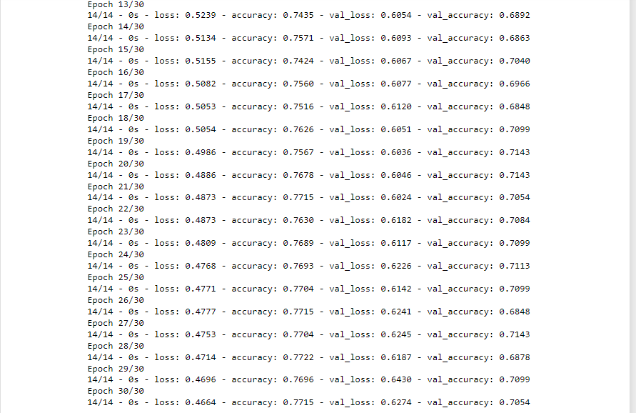

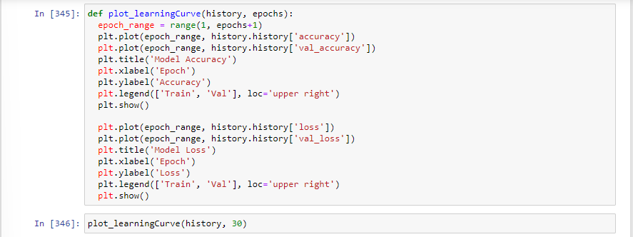

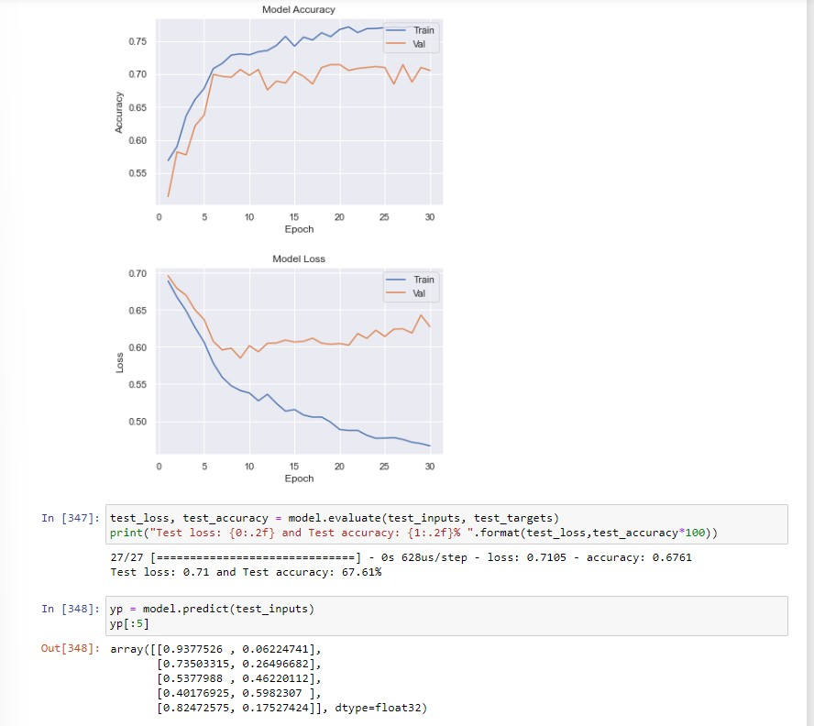

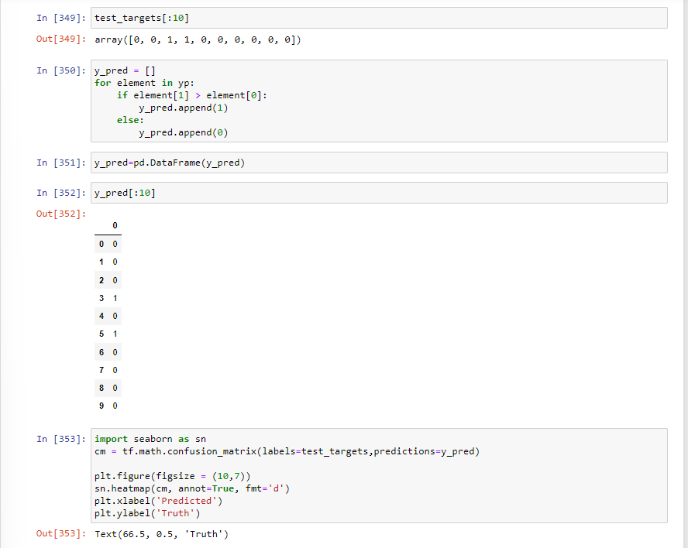

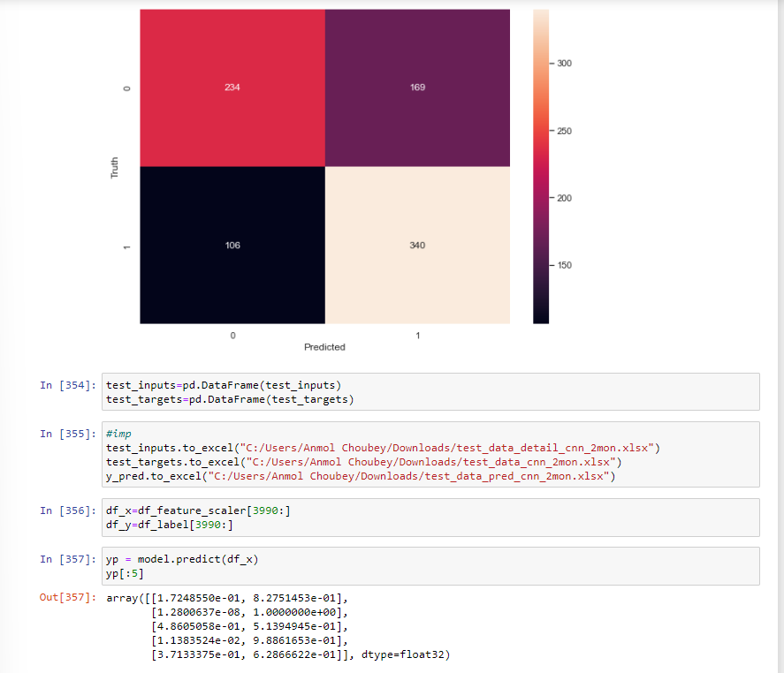

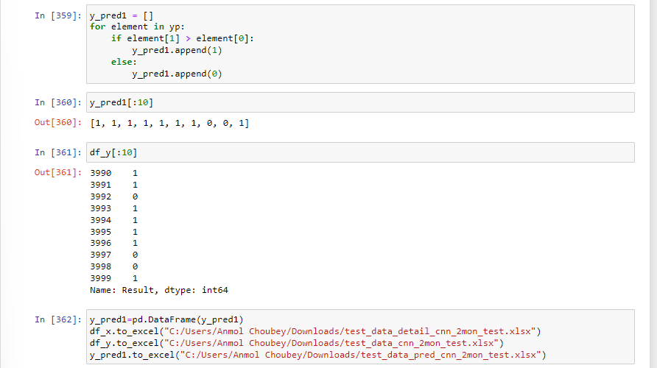

* + **LSTM**

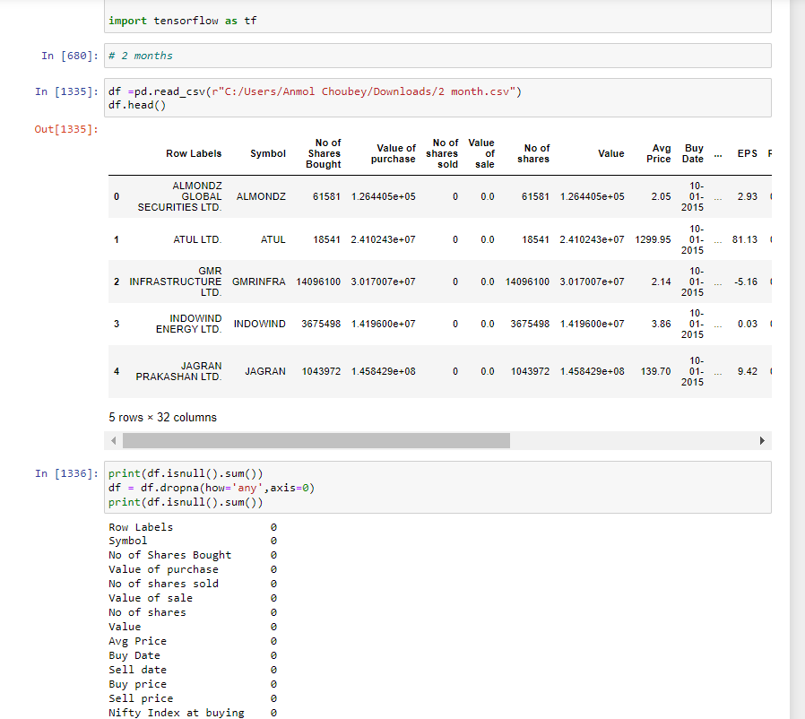

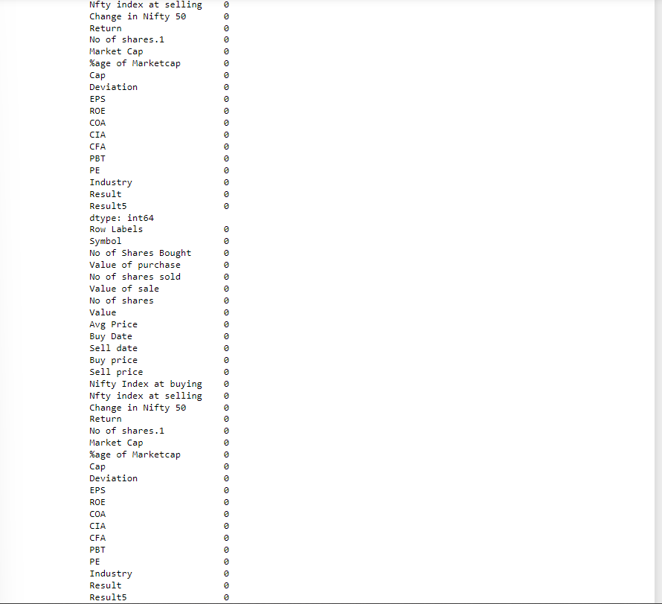

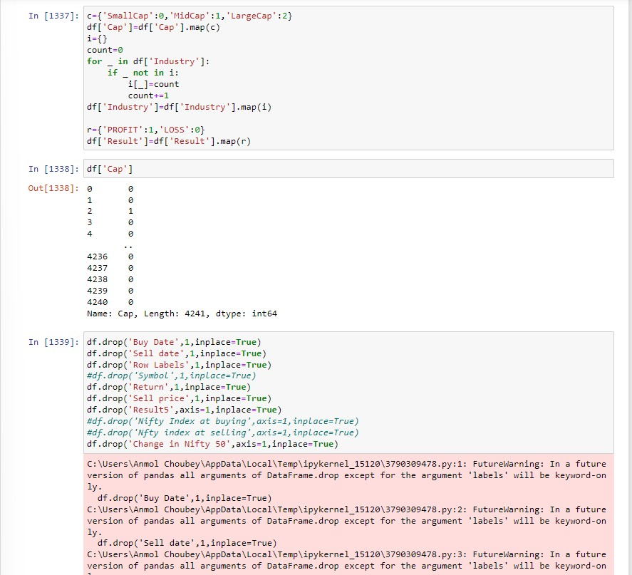

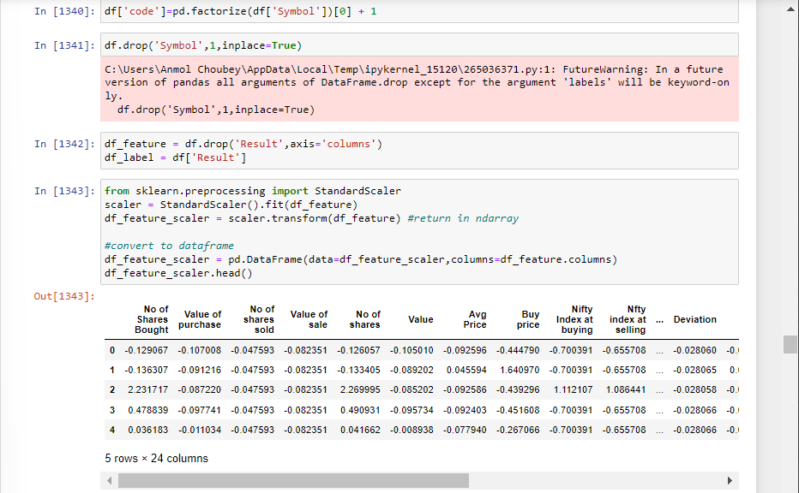

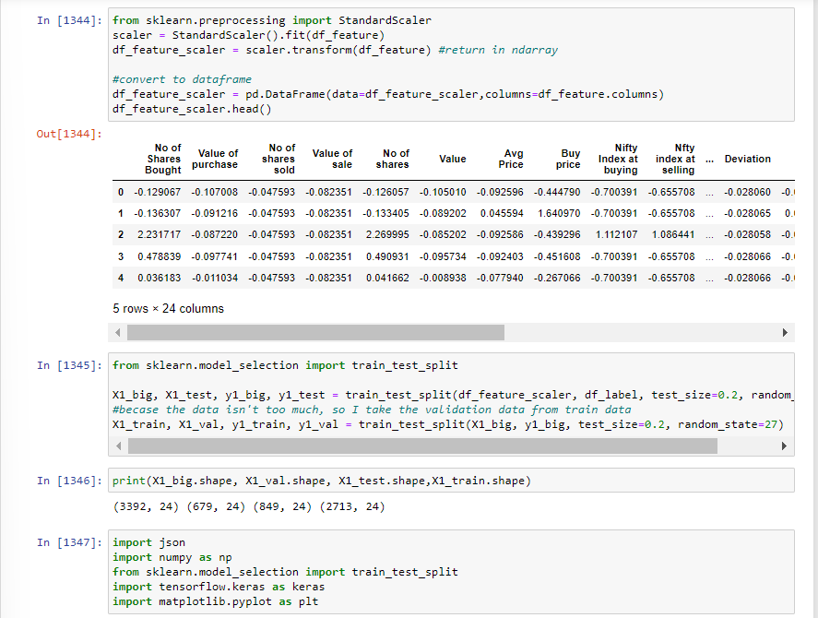

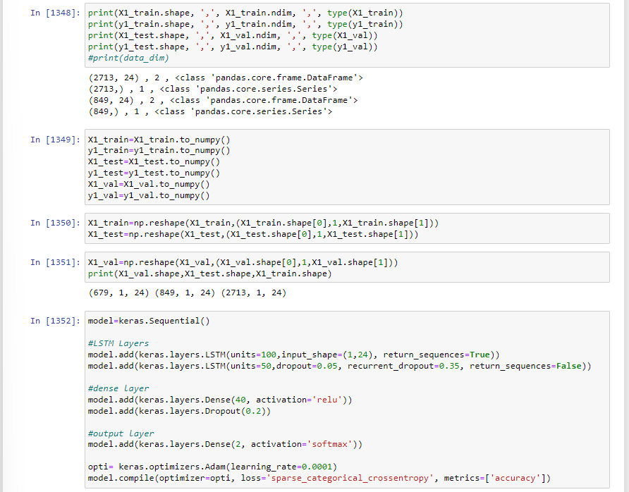

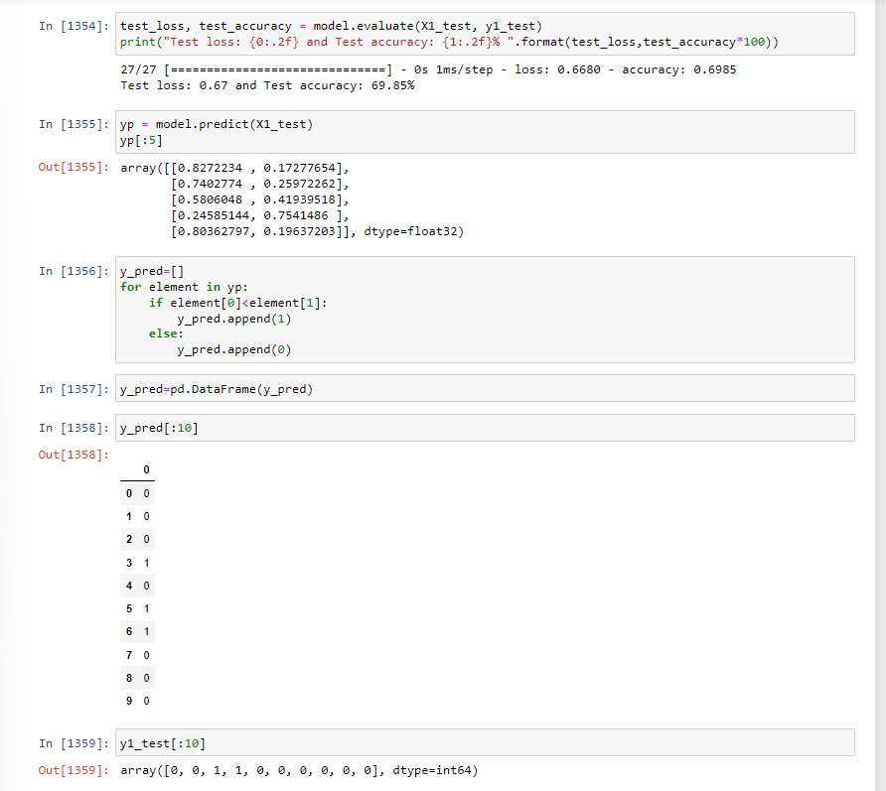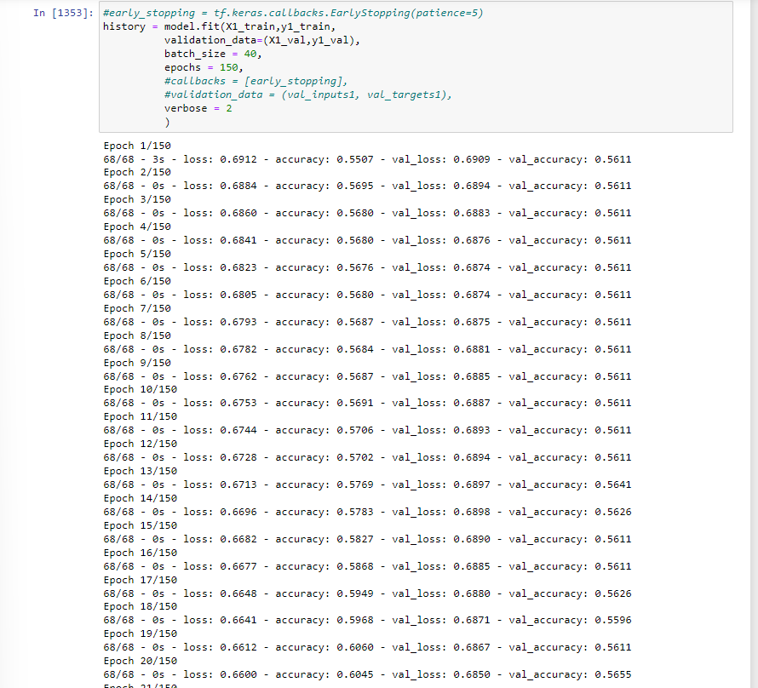

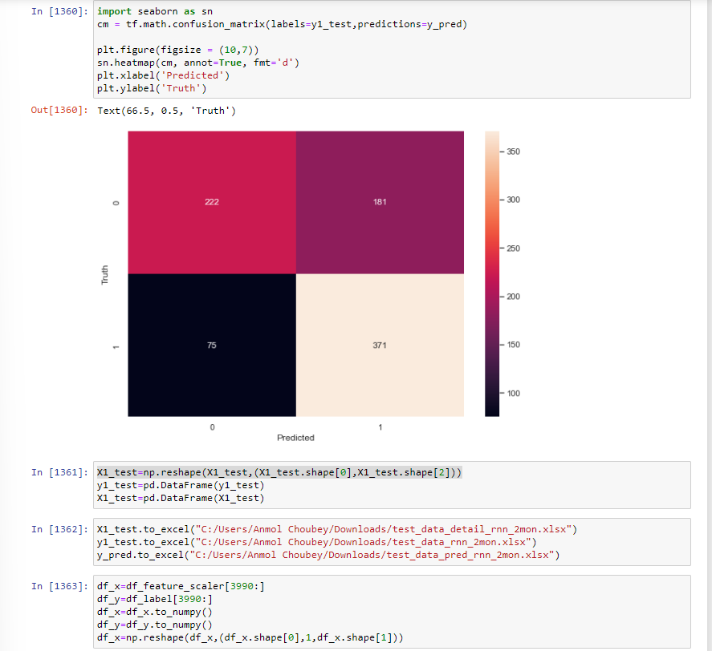

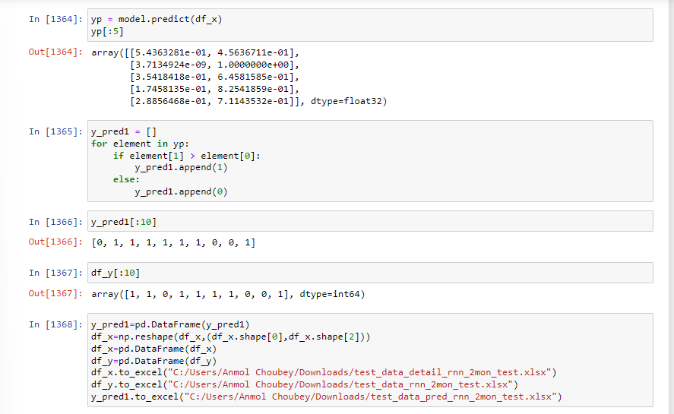

* + **FULLY CONNECTED LAYER**

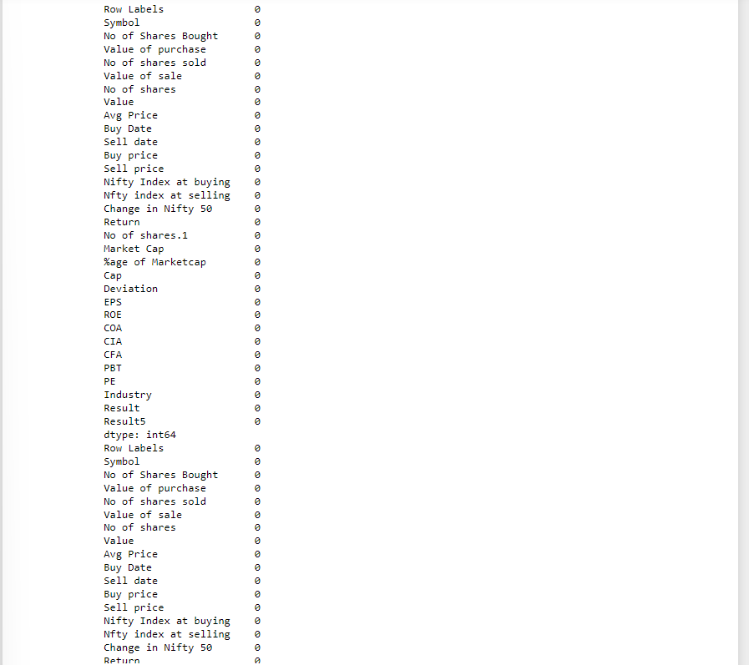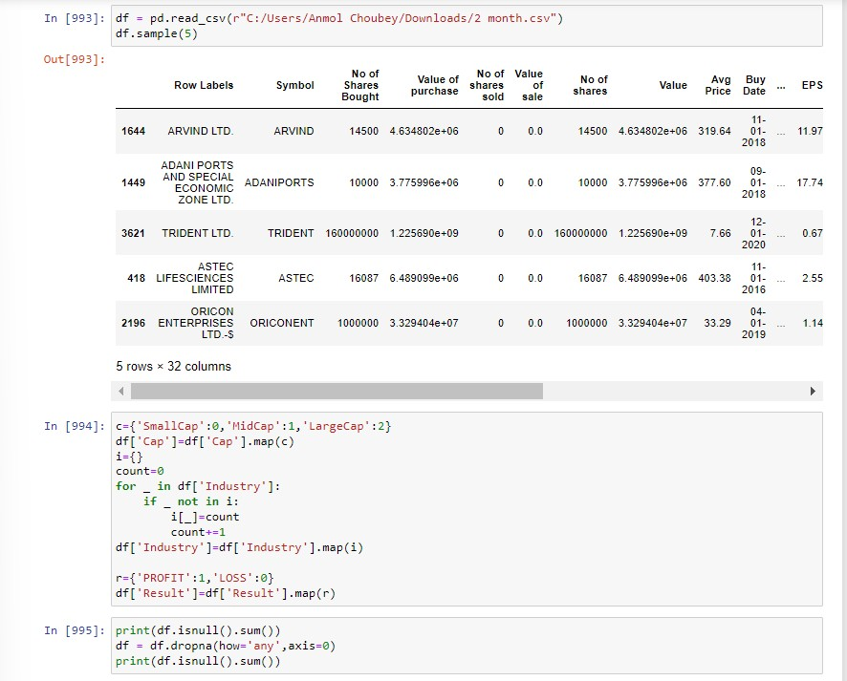

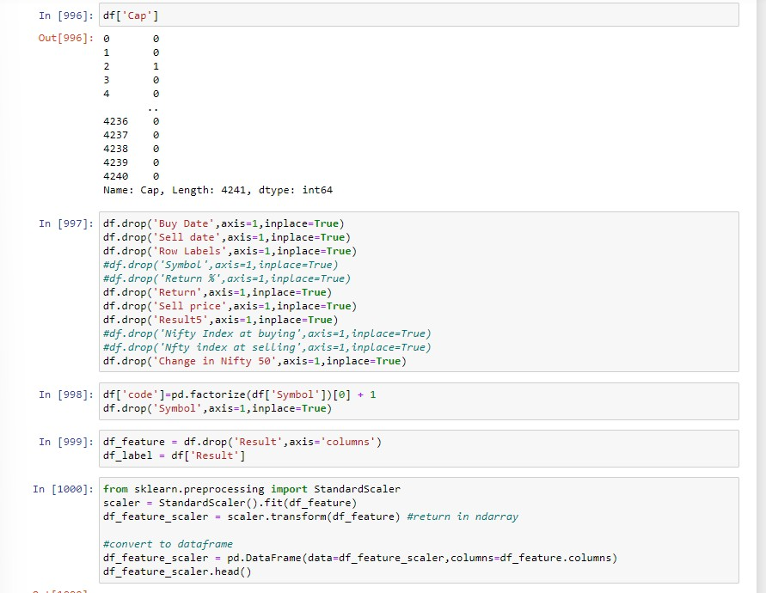

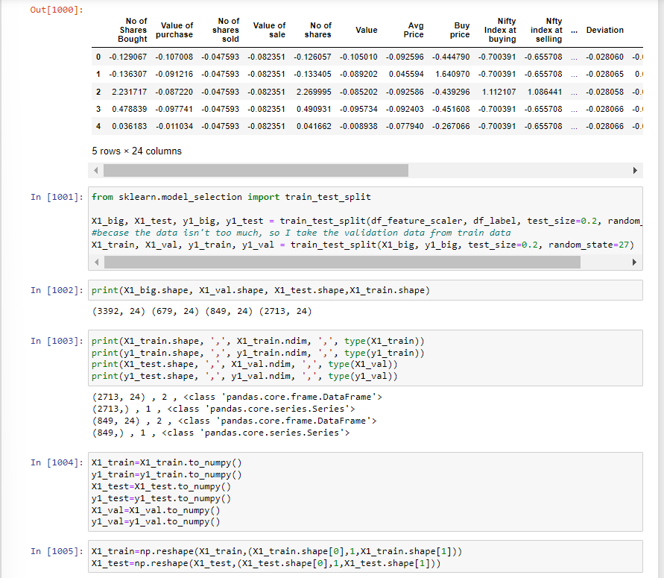

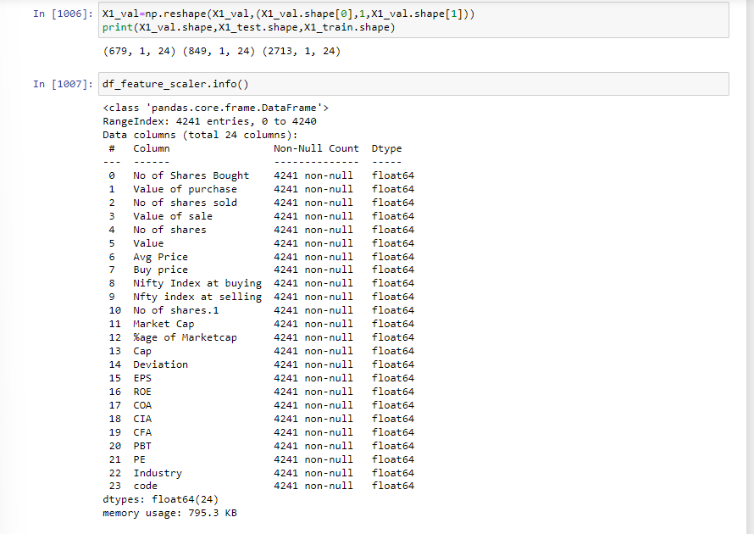

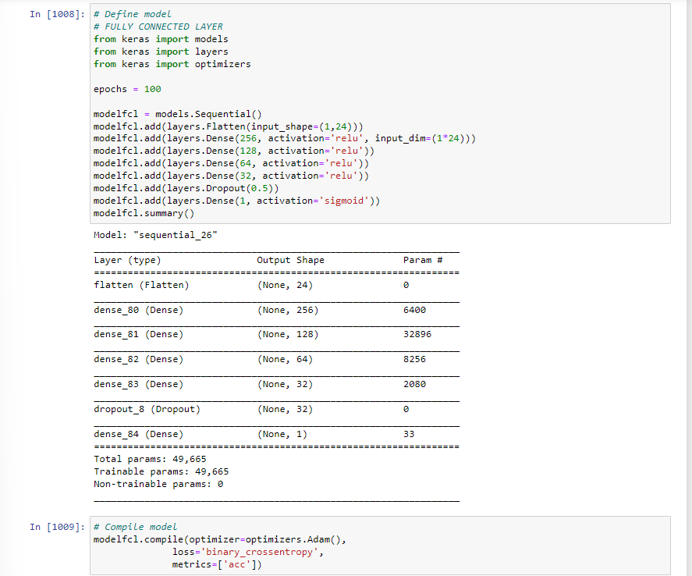

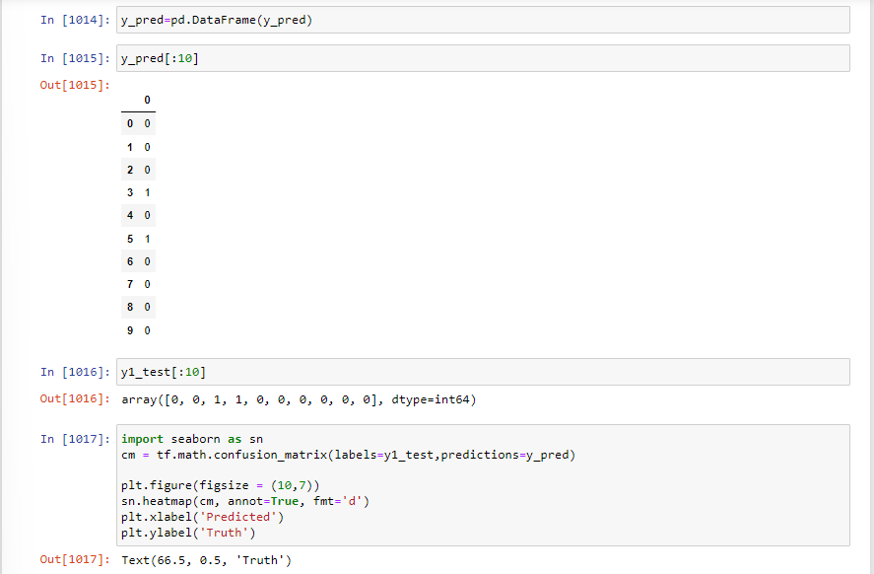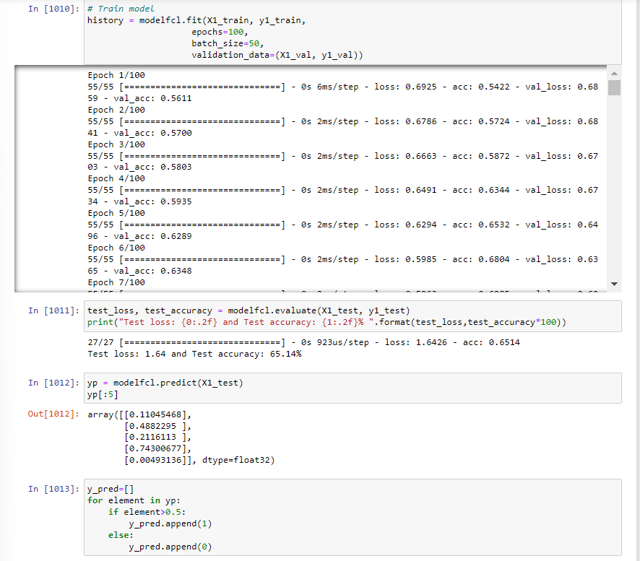

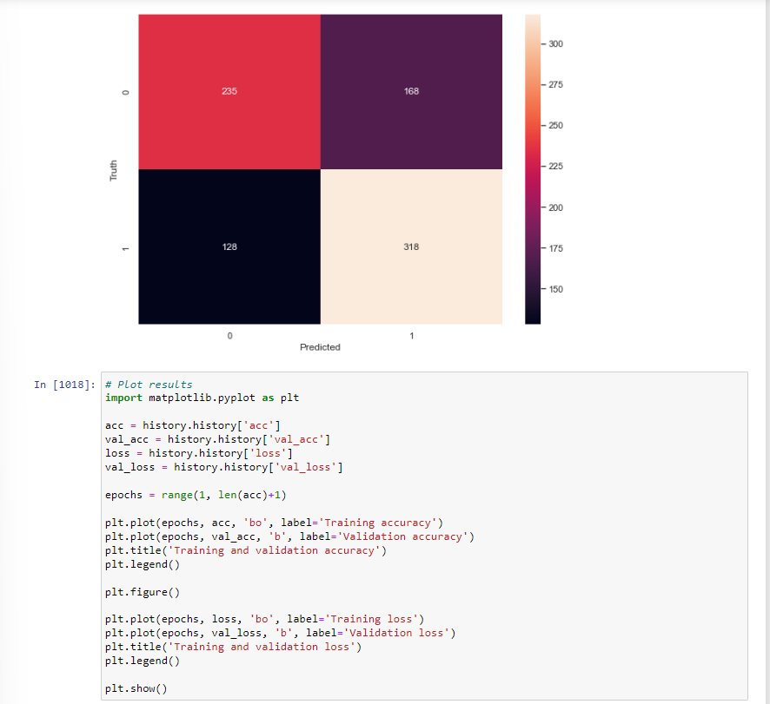

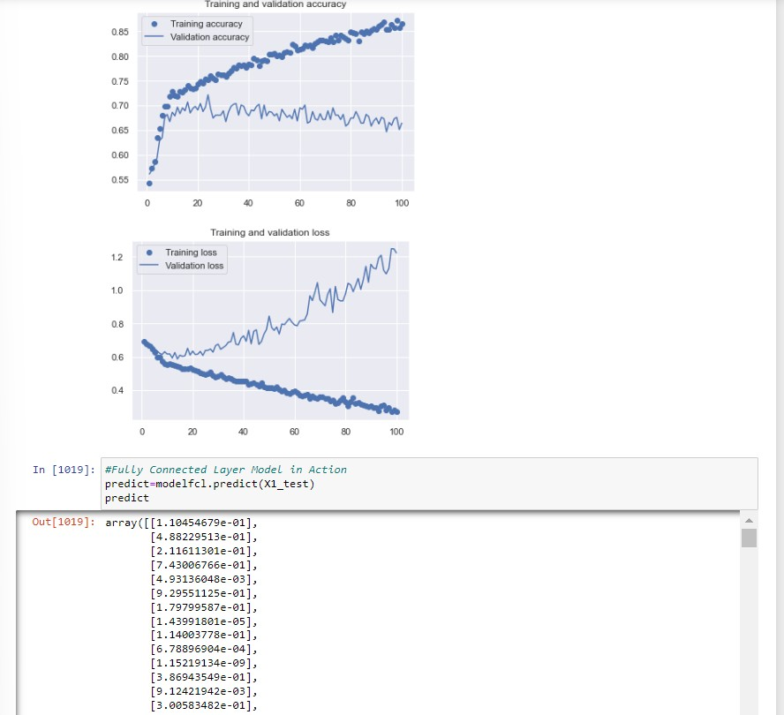

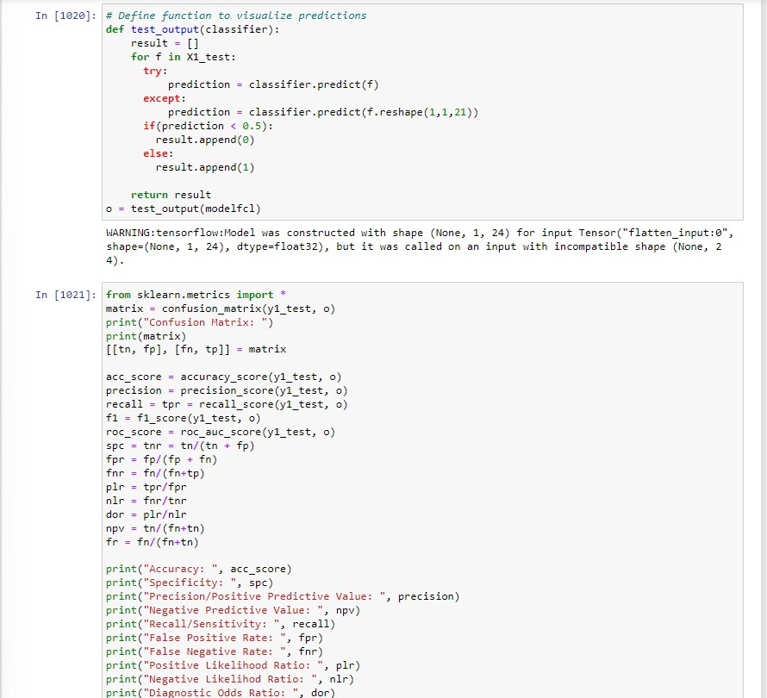

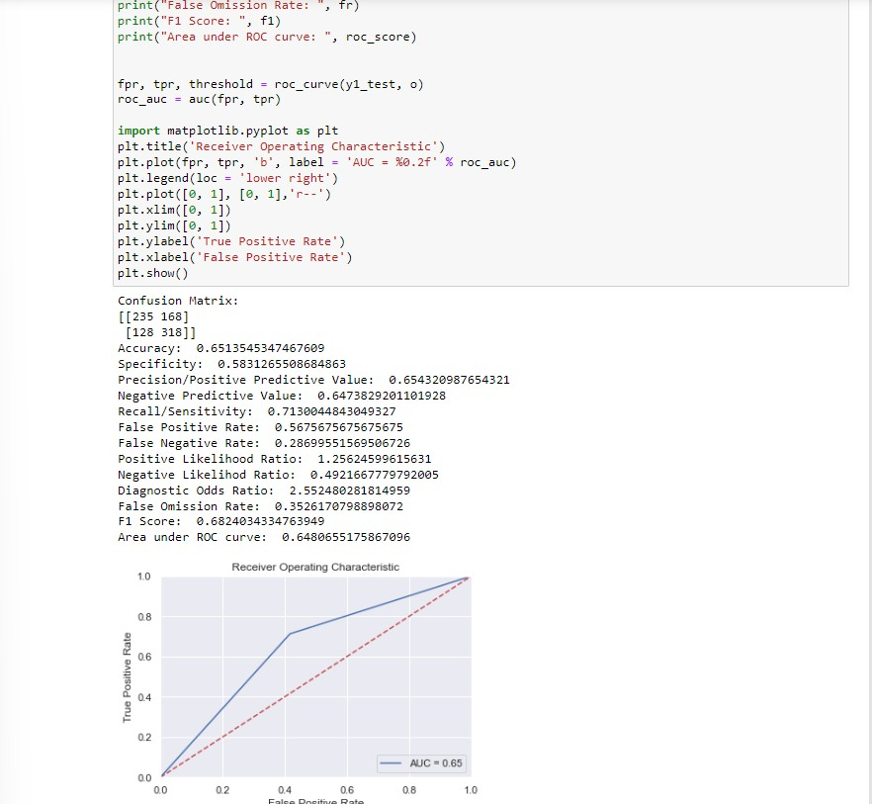

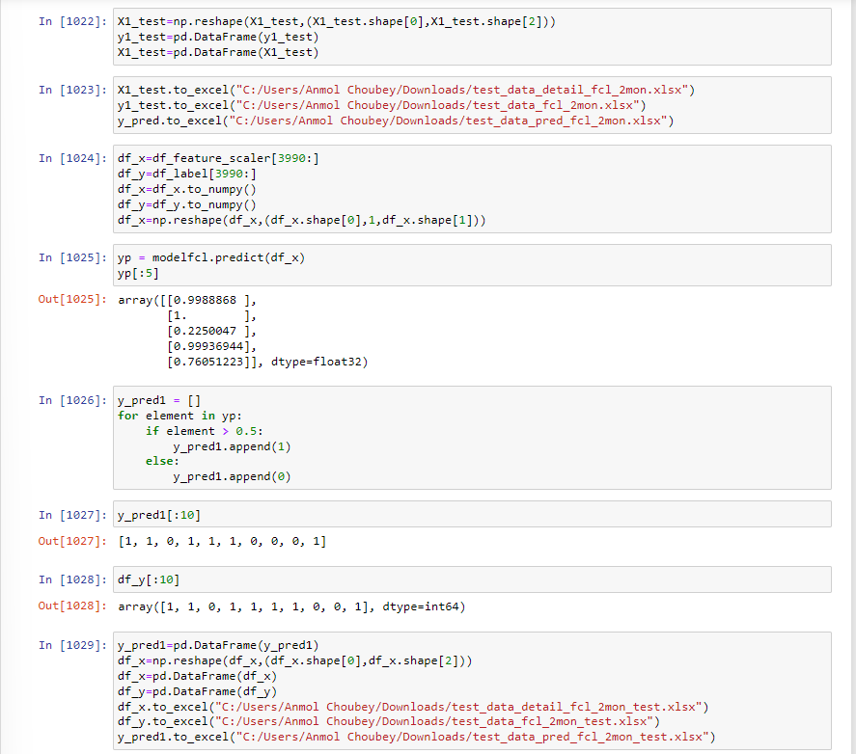

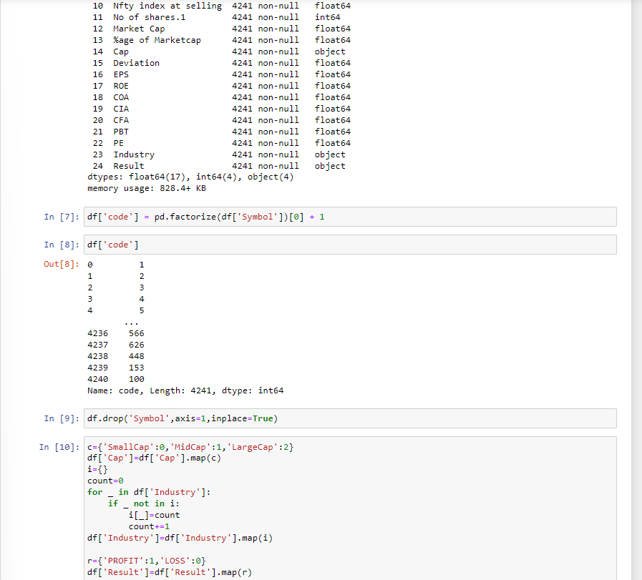

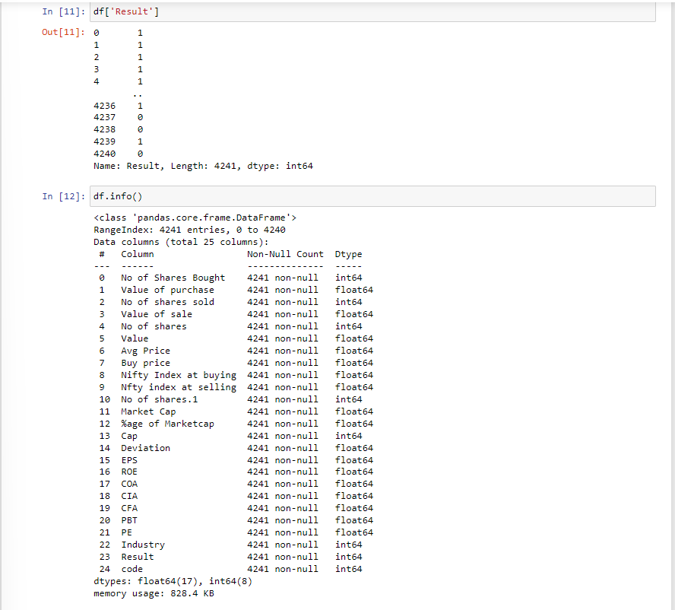

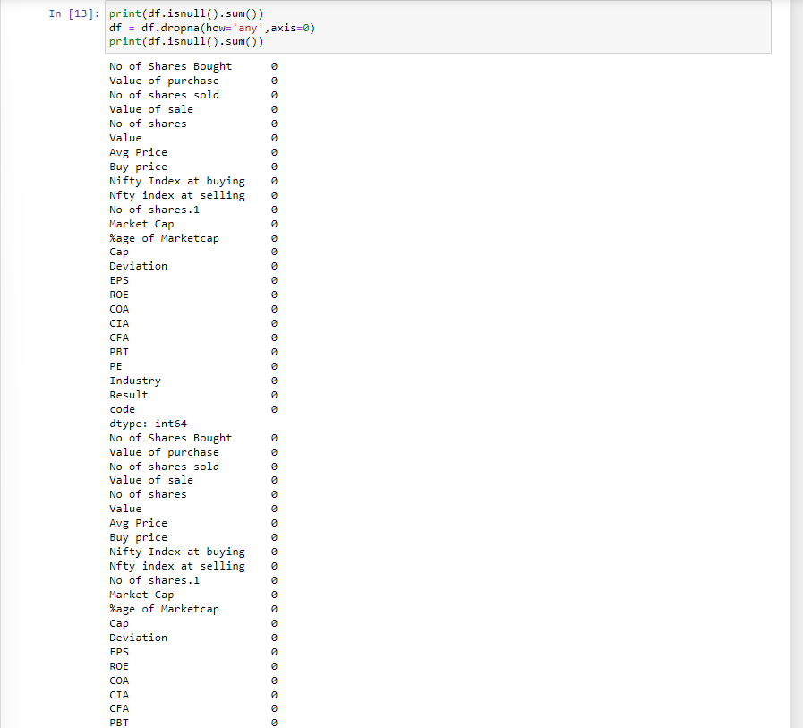

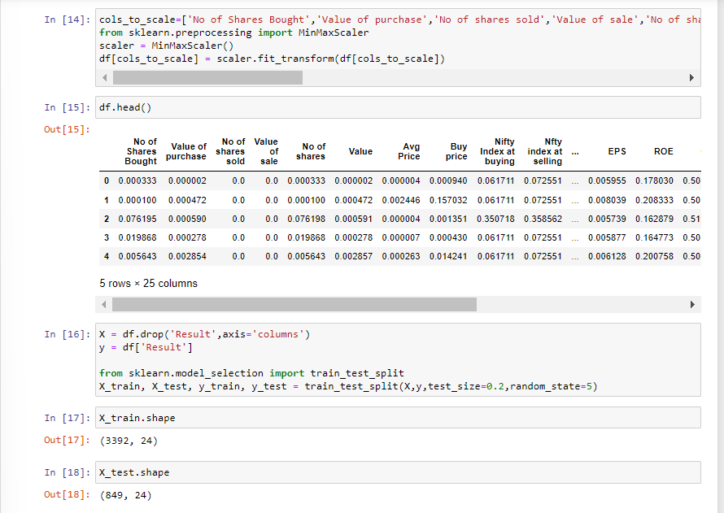

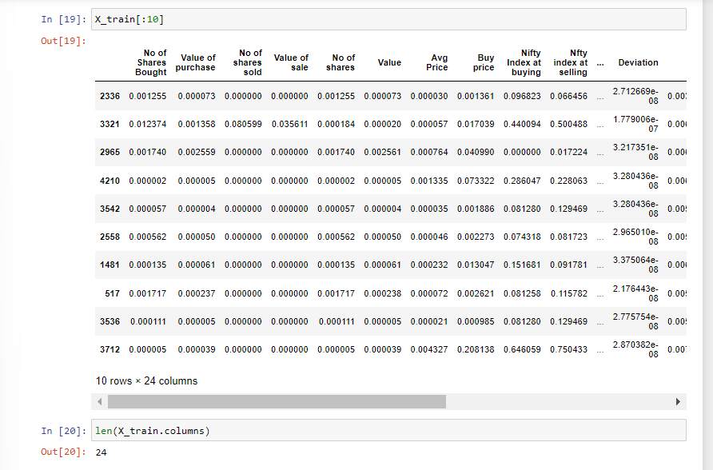

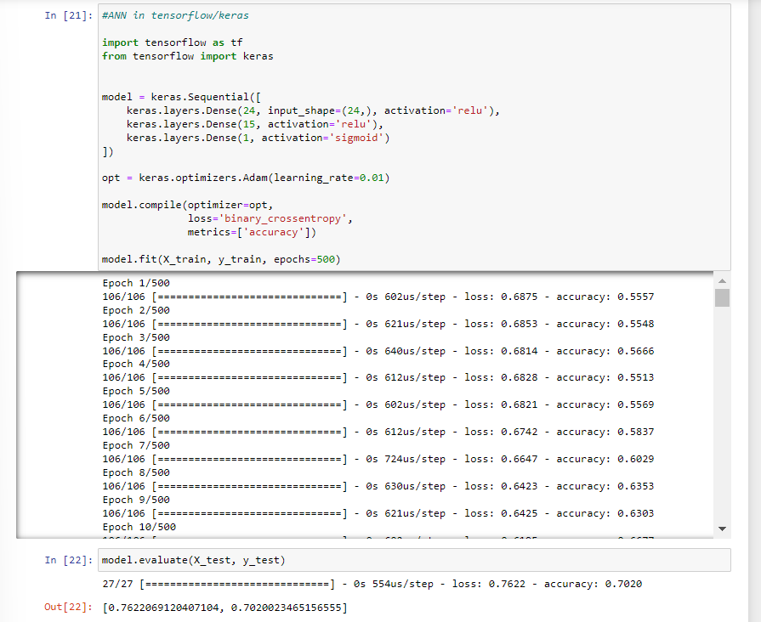

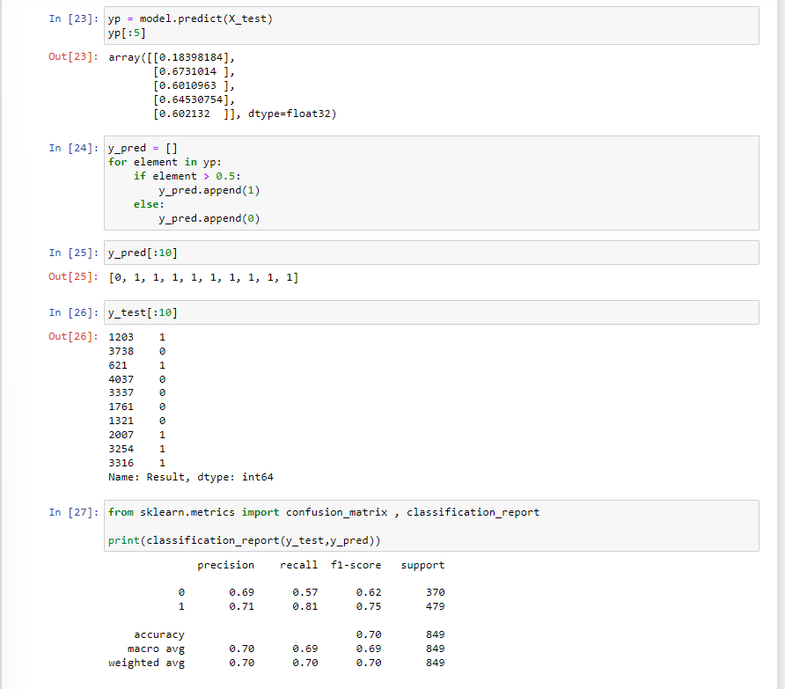

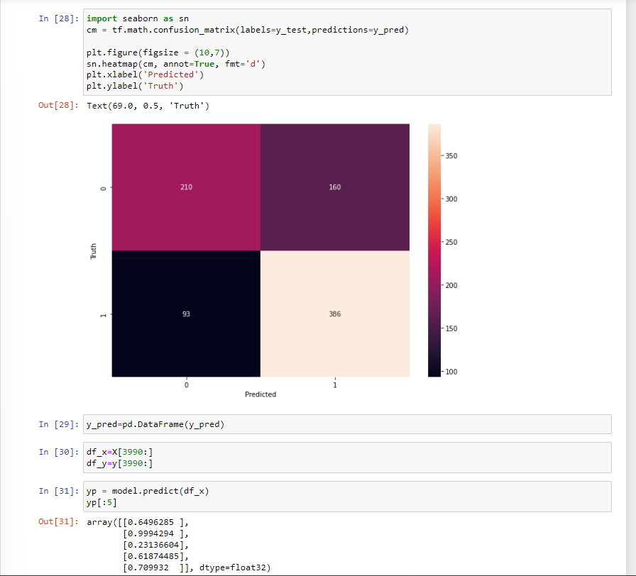

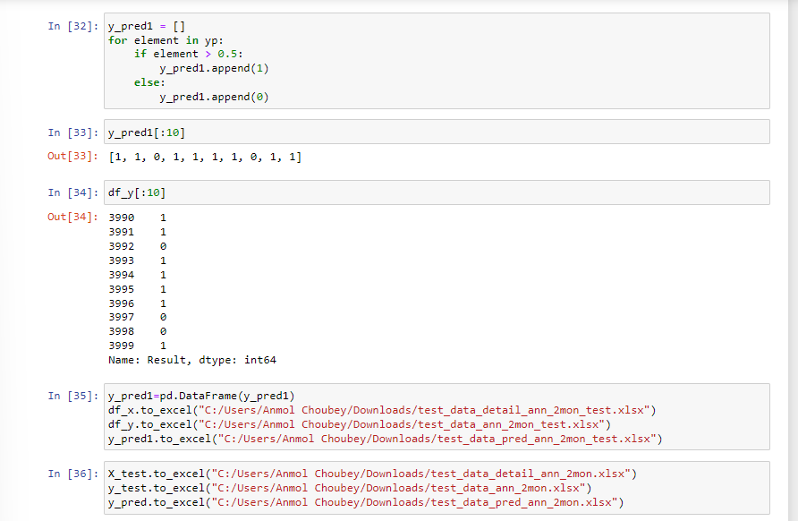

## Code for deep learning algorithms link for all the month data set and their respective Benchmarks